Masterplan Manual

Version 11.11

**What is Masterplan?**

Masterplan is an application that helps you to build D&D 4E campaigns. You can outline your plot structure, build encounters and maps, detail your campaign world, and create custom creatures and NPCs.

We call it the **Adventure Design Studio**. We think you’ll enjoy it.

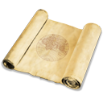

Creating a Project 3

The Plot Workspace 4

Linking Plot Points Together 5

Subplots 6

Search 7

Using Views 8

Completed / Skipped Plot Points 8

Adjusting Difficulty 8

Delve View and Map View 9

Party Goals 10

Game Elements 11

Encounters 11

Traps and Hazards 19

Skill Challenges 20

Quests 23

Maps 24

Campaign Background 26

The Encyclopedia 28

Adding Entries 28

DM Information 29

Groups 29

Encyclopedia Entry Templates 30

Using the Encyclopedia 30

Campaign Rules 32

Attachments 33

The Jotter 34

In-Session Reference 35

Party Breakdown 35

Random Generators 35

Tactical Maps 36

Map Editor 36

Using Maps With Encounters 41

Printing 43

Delve AutoBuild 44

Tile Breakdown 44

Regional Maps 45

Player Characters 46

Treasure Parcels 48

Creating Magic Item Handouts 50

Running Combat Encounters 52

Starting a Combat Encounter 52

Moving Down the Initiative Order 55

Creature Powers 57

Damage and Healing 58

Ongoing Effects 59

Drawing on the Map 60

Links between Map Tokens 61

Line of Sight 62

Adding Creatures During Combat 62

Adding Custom Tokens and Overlays 63

The Encounter Log 63

The Encounter Report 63

Layout 63

Ending an Encounter 64

Using the Player View 66

Other Tools 68

Project Overview 68

Campaign Settings 68

Information Screen 69

Custom Creatures and NPCs 69

Encounter Decks 70

Calendars 72

Creature Builder 80

Checklists 88

Import / Export 89

Libraries 92

Creatures 92

Creature Templates 92

Traps / Hazards 94

Skill Challenges 95

Magic Items 96

Map Tiles 97

Terrain Powers 98

Artifacts 99

Import / Export 100

Demographics 100

Password Protection 101

Customising Masterplan 102

Style Sheets 102

Add-Ins 102

Portability 103

# Creating a Project

The screen you will see when first running Masterplan is this:

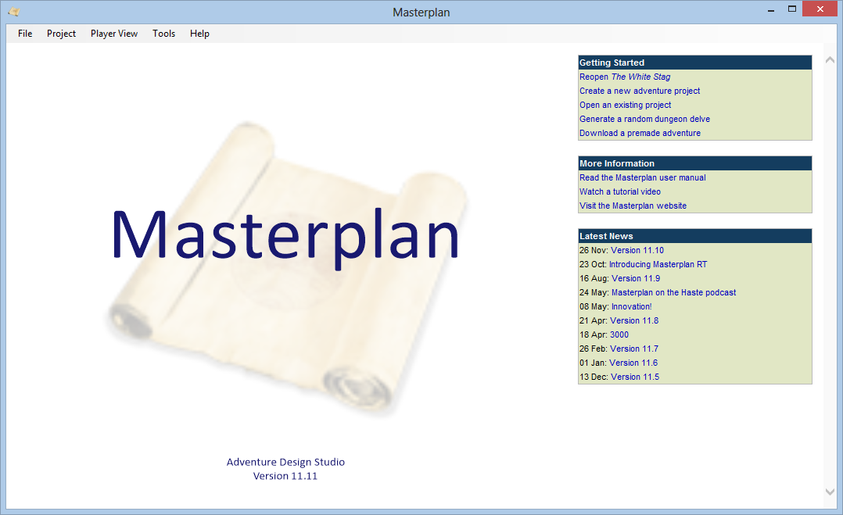

To create a project select **Create a new project** (or select **New Project** from the **File** menu, or press Ctrl+N). You will be asked for the name of your project, the number of characters in the party, and the party level. You can also specify the party’s starting XP value if you wish.

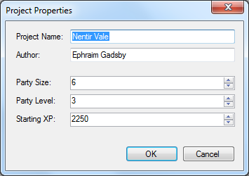

To change this information later, select **Project Properties** on the **Project** menu.

# The Plot Workspace

Masterplan allows you to create and link plot points to outline the flow of your plot.

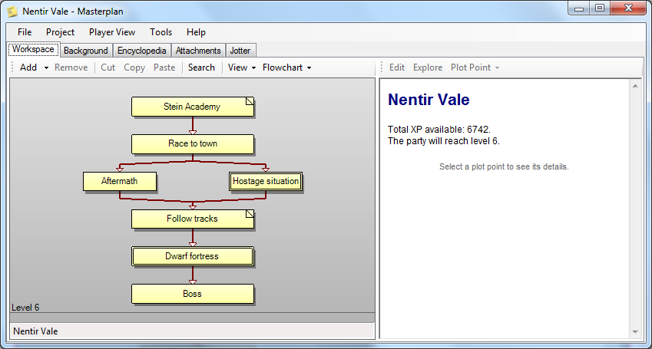

You can add and remove plot points from the toolbar. Double-clicking on a blank area of the workspace will also allow you to add a plot point. Double-clicking on a plot point, or selecting **Edit Plot Point** from the toolbar, allows you to edit it.

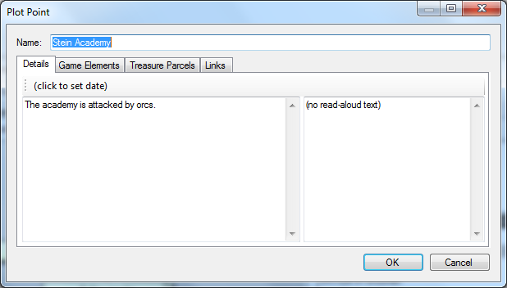

A plot point which has information on the **Details** page (either description or read-aloud text) will be shown in the workspace with its corner turned up.

You can use HTML or Markdown in your plot point details section.

## Linking Plot Points Together

There are many ways in which you can organise your workspace:

* To create a point with a link to an existing point, right-click on the point and select **Add Point**.
* To create a link between two points, left-click and drag the second point onto the first.
* You can re-order plot points by dragging them left or right; an I-beam will appear to indicate where the dragged plot point will be moved to.
* If you add a link between two points that you later want to remove, right-click on one of the points, select **Disconnect From**, and then select the name of the other point. Alternatively, double-click on one of the points and use the **Plot Connections** page to remove the link.

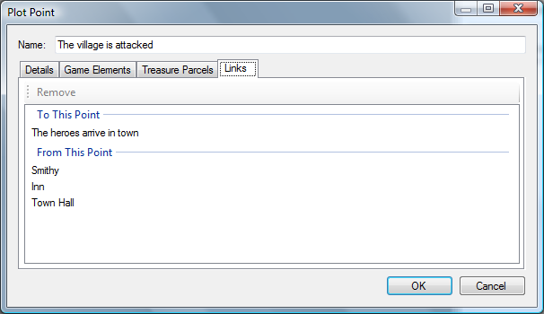

## Subplots

Each plot point can contain its own subplot. To keep your workspace clean, you can use subplots to define more complex pieces of your plot. If a plot point has a subplot, it will be shown with a double border.

To create or view a point’s subplot, select the point and press **Explore Subplot** on the toolbar (or hold shift while double-clicking on the plot point). This will bring you to the point’s subplot, where you can create plot points and link them together as usual.

You can right-click on a plot point and select **Move to Subplot** to move that point into to the subplot of one of the points that leads into it.

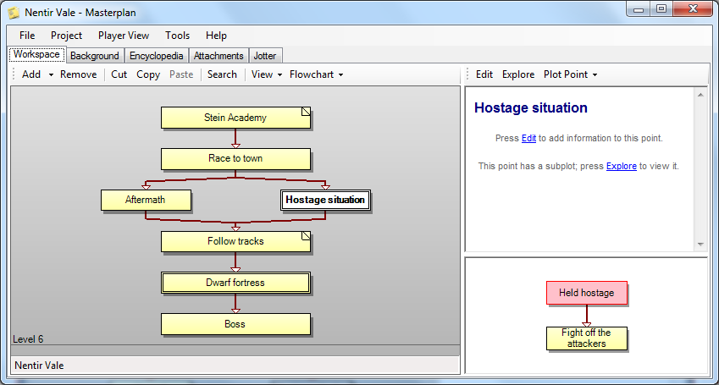

To return to the main plot, you can use the link at the bottom of the screen. You can also use the up / down arrows at the top right of the plot workspace to quickly move up or down.

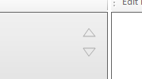

### Navigator

If you have a plot with multiple subplots, you might find the navigation panel useful. It can be turned on from the View menu. The navigation panel shows all the subplots in your project, allowing you to switch between them easily.

You can also drag and drop plot points between subplots using the navigator.

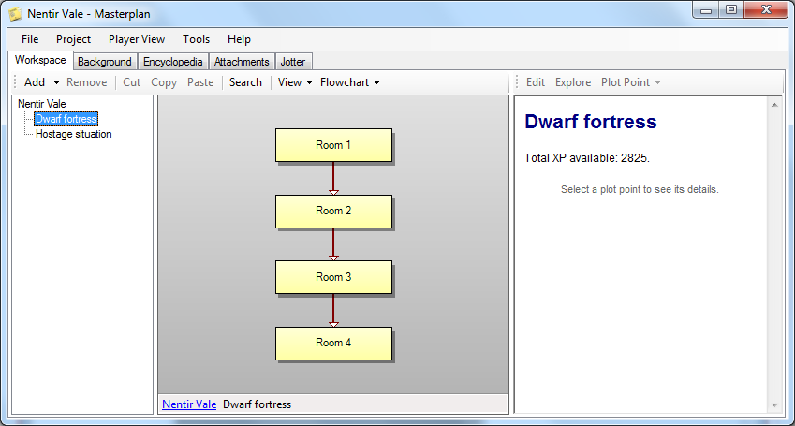

## Search

If you have a complex plot, you can use the **Search** function on the toolbar to find information. When you type in the search box, any points that do not contain the search terms are displayed only in outline form.

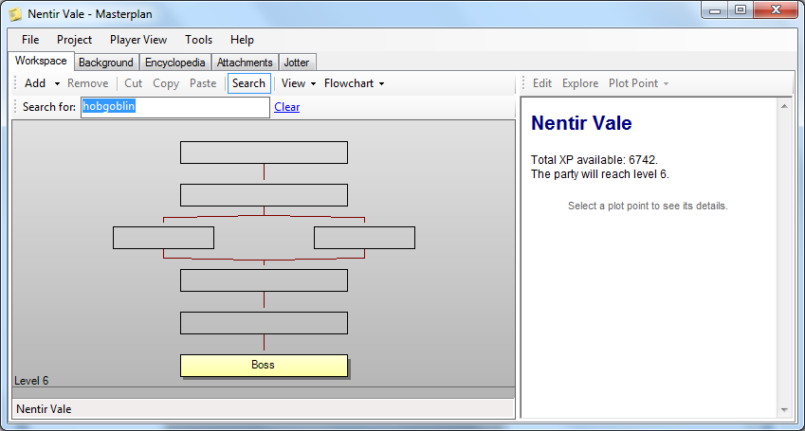

## Using Views

You can use the options on the **View** menu to show only those plot points which contain encounters, traps, skill challenges, quests and treasure parcels.

By default Masterplan will show you the places where the PCs are likely to have gained enough XP to level up; you can disable this option by deselecting **Levelling** on the **View** menu. The amount of XP the party gains can be calculated in two ways:

* If **Maximum Available XP** (on the **Flowchart** menu) is selected, Masterplan assumes the PCs will get XP from all plot points.
* If **Maximum Available XP** is not checked, Masterplan assumes that where there are multiple plot points in a horizontal row, the PCs will gain the average of the different amounts available.

Another option on the **View** menu is **Highlighting**; this will highlight the plot points which are linked to the currently selected point. This can be useful if you find it difficult to track the flow of a complex plot.

## Completed / Skipped Plot Points

You can right-click on a plot point in the workspace to specify that it has been completed by your party or skipped altogether; such plot points are dimmed in the workspace.

Any XP which would be granted by skipped plot points is not counted.

## Adjusting Difficulty

If you want to quickly make an entire plot more or less difficult, you can do so easily. First open the plot or subplot in the workspace, and then select **Adjust Difficulty** from the **Advanced** button on the toolbar; you can then specify how many levels more or less difficult you want the plot to be.

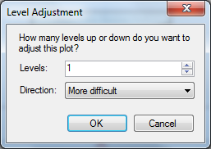

When you press OK, each creature, trap, skill challenge and quest in the plot will be automatically adjusted up or down.

## Delve View and Map View

By default Masterplan assumes you’re creating your plot structure first, and then creating maps to accommodate it. However, you may prefer to work in the other direction, creating a map first and then populating it with encounters.

If you would like to do this, the right-hand panel contains a link to activate **Delve View** or **Map View**, which allow you to select (or create) a map which will replace the flowchart in the workspace.

* If you want to work from a tactical map (for example, you are creating a dungeon delve and want to set up an encounter for each room), select **Delve View**.
* If you want to work from a regional map (for example, you are detailing various encounters and skill challenges that might occur as the heroes travel around a city), select **Map View**.

You can then select map areas and create plot points (encounters, skill challenges, etc) from them.

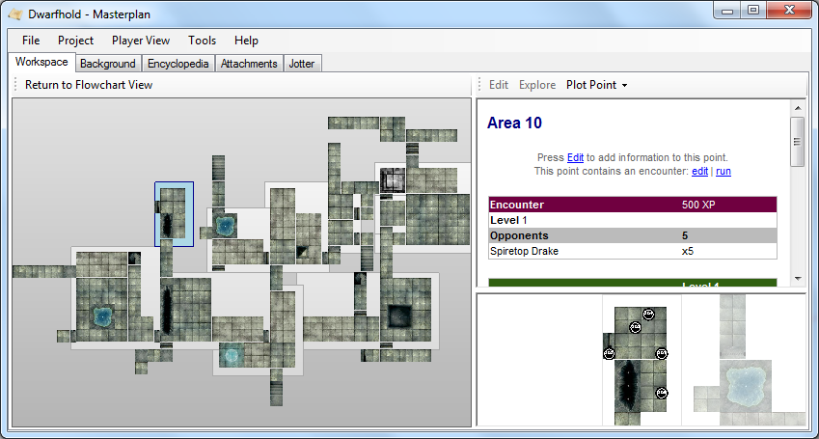

For information about how to create tactical or regional maps, and how to add areas and locations to them, see the relevant sections later on in this manual.

## Party Goals

If the plot workspace seems too daunting, you can instead define party goals by clicking on the **Party Goals** link.

Typically a plotline will have a single top-level goal, representing the party’s primary quest. Beneath this goal there may be several prerequisite goals, representing the complications which must be overcome to complete the primary quest. This structure can be extended many levels deep, and goals can be dragged and dropped into new locations as desired.

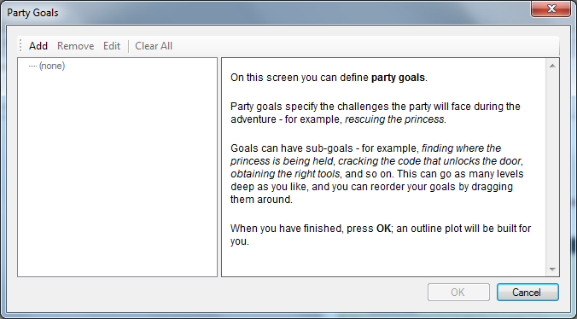

When you press OK the goal structure will be used to build a plotline automatically.

# Game Elements

Plot points can contain various types of game element: encounters, traps, skill challenges, quests and maps.

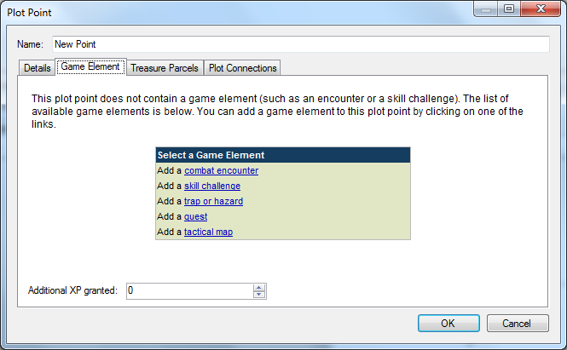

## Encounters

Plot points can contain encounters. To add an encounter to a point, double-click on it; on the **Game Elements** page click the **Combat Encounter** link.

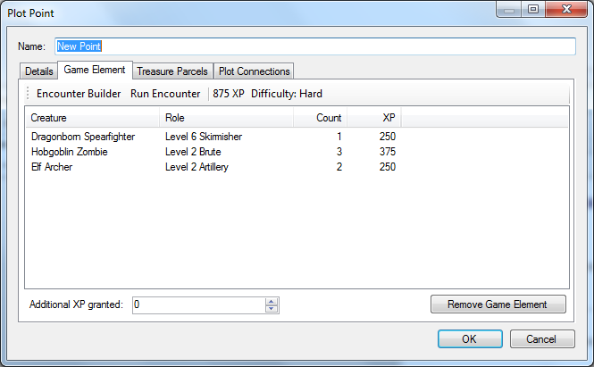

To add creatures to an encounter, click the **Edit** button to bring up the Encounter Builder.

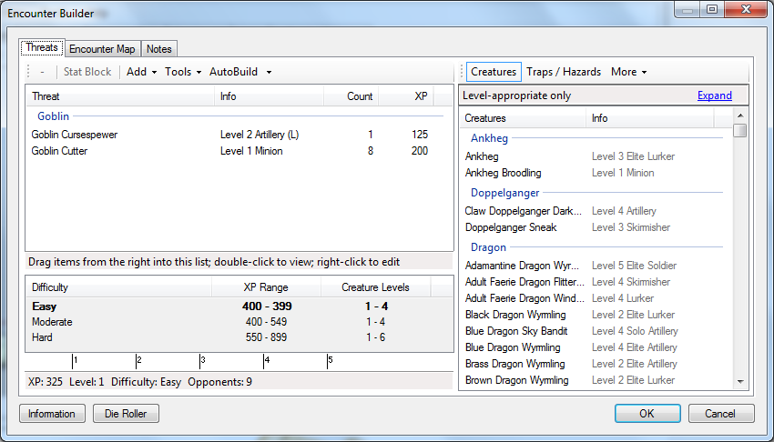

The panel at the bottom left of the encounter builder shows the appropriate XP values and creature levels that are appropriate for a party of the given size and level (you can change the party size and level that this calculation is based on by clicking on the link).

By default, creatures of lower or higher levels are not shown in the right-hand list (you can override this by deselecting **Filter by Level** from the **Filter List** menu on the right-hand list).

If the encounter poses an inappropriate challenge (either too easy or too difficult), the plot point will turn red in the workspace.

If you press the **Expand** link you can use various criteria to filter the creatures in the list.

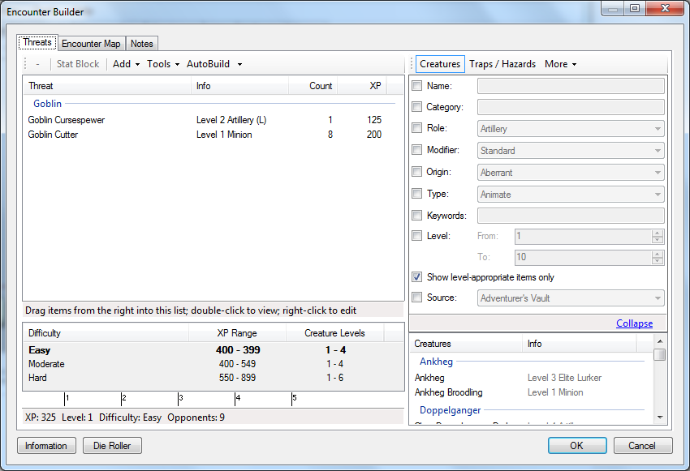

### Adding Creatures

You can add creatures to the encounter by selecting them from the list on the right and dragging them into the list on the left. The XP value and difficulty of the encounter will be updated automatically and shown at the bottom of the screen.

You can change the number of creatures in the encounter by selecting a creature and using the + and – buttons. If you reduce the number of a particular creature to 0, it will be removed from the list.

If you hold down the Shift key when pressing the + or – buttons a level adjustment will be applied, allowing you to quickly change the level of a standard creature. The creature’s level, XP value, defences, hit points and attack bonuses will be updated accordingly. To remove a creature’s level adjustment, right-click it and choose **Remove Level Adjustment**.

If you right-click a creature in the encounter and select **Set Faction** you can mark creatures as being neutral (in which case they will not add to the encounter XP value) or allied (in which case their XP value is subtracted from the XP total).

You can set up your encounter to have multiple waves of opponents by right-clicking on a creature in the encounter and selecting **Set Wave**.

### Adding Creature Templates

You can add templates to the creatures in an encounter by selecting **Creature Templates** from the toolbar above the right-hand list (this option will not be available if no templates have been defined). Select a template and drag it onto a creature to apply the template to that creature; the encounter’s XP value will be updated accordingly.

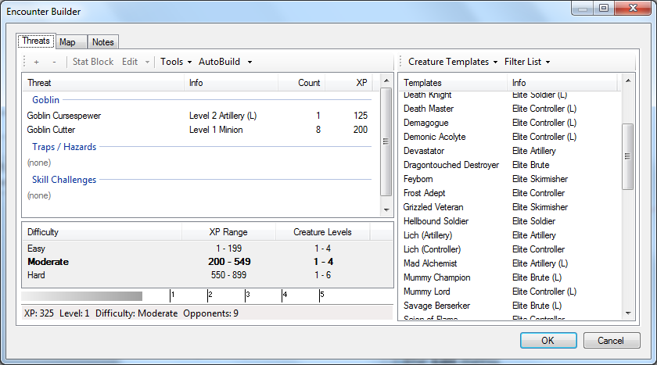

To remove a template from a creature, select it and choose **Remove Template** from the **Edit** menu.

### Adding Monster Themes

You can add a theme to a creature in an encounter by opening the encounter builder, selecting the creature, and selecting **Apply Theme** from the **Edit** menu.

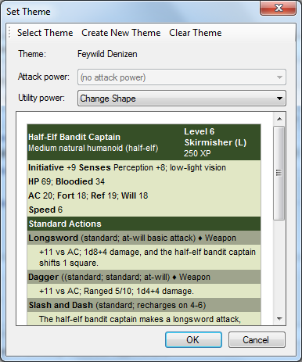

This screen allows you to select (or create) a monster theme, and to choose the attack and utility powers granted by it.

To remove the theme from the creature, select **Clear Theme** from the **Edit** menu.

If you want to apply a theme to all the creatures in the encounter, rather than a single creature, select **Apply Theme to All** from the **Tools** menu. Select a theme and each different type of creature in the encounter will be updated with an appropriate attack and utility power from the theme.

### Adding NPCs

You can add NPCs to an encounter by selecting **NPCs** from the toolbar above the right-hand list (this option will not be available if your project contains no NPCs). Select an NPC from the right-hand list and drag it onto the left-hand list to add it to the encounter; the encounter’s XP value will be updated accordingly.

### Adding Traps and Hazards

There are two ways to add traps and hazards to your encounter:

* You can add a predefined trap or hazard by selecting **Traps / Hazards** from the toolbar above the right-hand list (this option will not be available if no traps have been defined). Select a trap and drag it into the left-hand list; the encounter’s XP value will be updated accordingly.
* You can add a custom trap or hazard by selecting **Custom Trap / Hazard** from the **Tools** menu.

You can remove a trap from the encounter by selecting it and pressing **Remove** on the toolbar.

### Adding Skill Challenges

There are two ways to add skill challenges to your encounter:

* You can add a predefined skill challenge by selecting **Skill Challenges** from the toolbar above the right-hand list (this option will not be available if no skill challenges have been defined). Select a skill challenge and drag it into the left-hand list; the encounter’s XP value will be updated accordingly.
* You can add a custom skill challenge by selecting **Custom Skill Challenge** from the **Tools** menu.

You can remove a skill challenge from the encounter by selecting it and pressing **Remove** on the toolbar.

### Using Encounter Templates

You can choose to build your encounter using one of the defined encounter templates. Encounter templates define groups of creatures which work well together in a combat encounter.

Select **Use Encounter Template** from the **Tools** menu to see a list of the encounter templates that are available (this list may change depending on the project level and the available creatures).

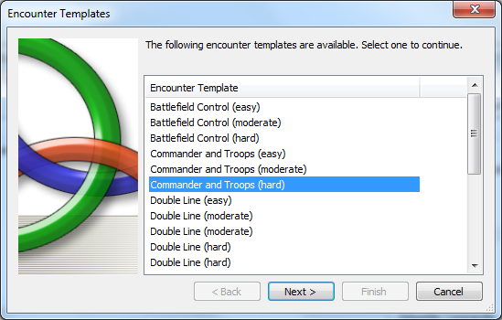

Select a template and press **Next**. You will then be asked to fill each of the slots in the template by selecting a creature for it.

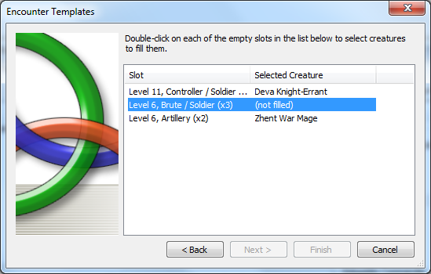

When this is complete, press **Finish** to update your encounter.

### Using Enounter Decks

You can use an encounter deck (see the section on Encounter Decks) to select creatures for an encounter. Open the encounter builder and choose the deck you want to use by selecting **Use Encounter Deck** from the **Tools** menu. Cards will be randomly drawn from the deck and added to the encounter; the encounter difficulty and XP value will be automatically updated.

You can also draw an encounter from a deck by opening the list of encounter decks (select **Encounter Decks** from the **Project** menu) and pressing the **Run Encounter** button; you can optionally select a map to use for the encounter.

### AutoBuild

If you don’t want to spend time building the encounter yourself, Masterplan provides an **AutoBuild** feature which will generate a level-appropriate encounter containing random creatures.

You can exercise a degree of control over this process by selecting the **Advanced** option, which allows you to specify the encounter template, the difficulty of the encounter, the level of the party and the types of creatures that should be considered.

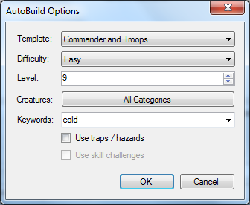

### Encounter Notes

You can add notes to your encounter to cover topics such as creature tactics, illumination and so forth – some blank notes are created to cover standard notes you may want to add. Any information you add here is displayed when you select the encounter in the workspace, and when the encounter is run.

You can use HTML or Markdown in encounter notes.

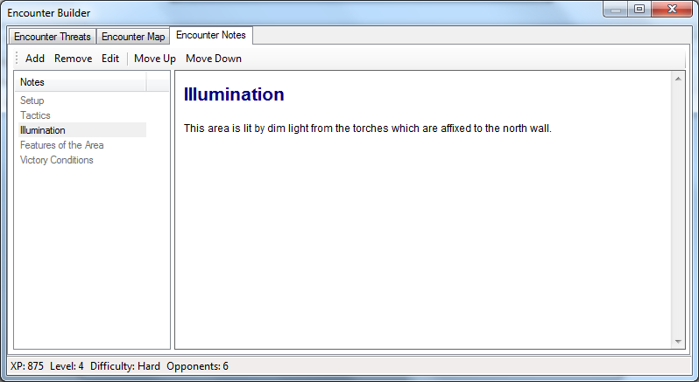

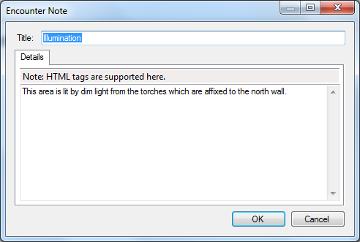

## Traps and Hazards

A plot point can contain a trap or hazard. To add a trap or hazard to a point, double-click on it; on the **Game Elements** page click the **Trap or Hazard** link.

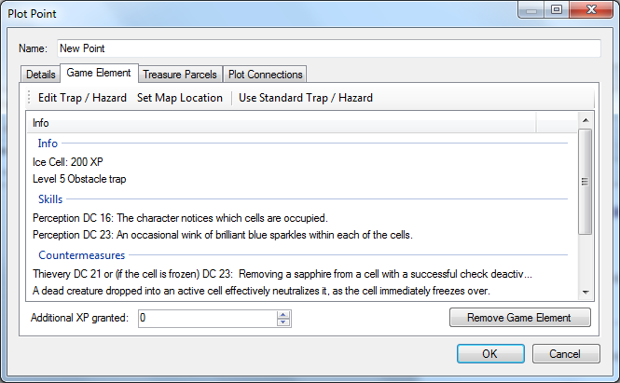

This creates a blank trap. To set the trap information, press the **Edit Trap / Hazard** button on the toolbar. This allows you to change the trap’s statistics (such as level, role and attack data).

Alternatively you can import a predefined trap / hazard from a library by pressing the **Use Standard Trap / Hazard** button; this clears the current trap and replaces it with the information from the selected trap.

**Note**: You can add predefined traps and hazards to an encounter by opening the encounter builder and switching to **Traps / Hazards** on the toolbar above the right-hand list.

## Skill Challenges

Like encounters, plot points can contain skill challenges. To add a skill challenge to a point, double-click on it; on the **Game Elements** page click the **Skill Challenge** link.

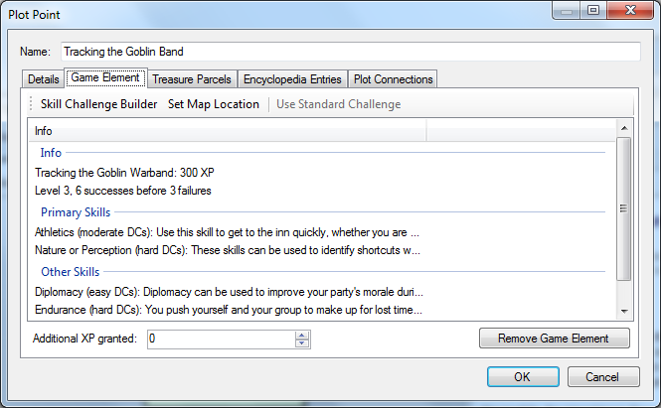

This creates a blank skill challenge. To set the skill challenge information, press the **Skill Challenge Builder** button on the toolbar. This allows you to change the level and complexity of the challenge (the challenge’s XP value will be updated automatically); the challenge level equals the party level by default. You can also enter the consequences of success and failure, and information about the skills which can be used in the challenge.

Alternatively you can import a predefined challenge from a library by pressing the **Use Standard Challenge** button; this clears the current skill challenge and replaces it with the information from the selected challenge.

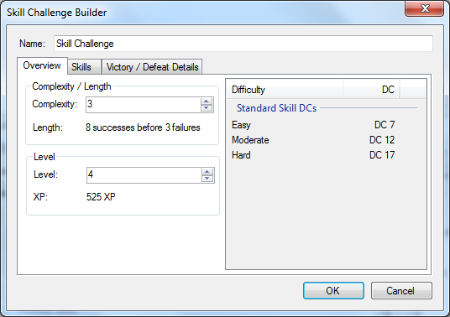

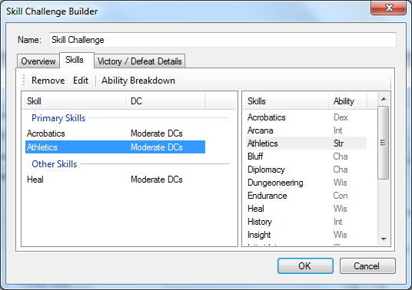

You can add skills to the skill challenge by moving to the **Skills** page and dragging them from the right-hand list into the left-hand list. You can then specify the skill’s DC level, and give details about how the skill should be used in the challenge.

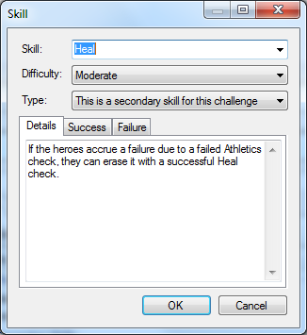

You can track your party’s progress on a skill challenge from the Masterplan main screen.

**Note**: You can add predefined skill challenges to an encounter by opening the encounter builder and switching to **Skill Challenges** on the toolbar above the right-hand list.

## Quests

Like encounters and skill challenges, plot points can contain quests. To add a quest to a point, double-click on it; on the **Game Elements** page click the **Quest** button.

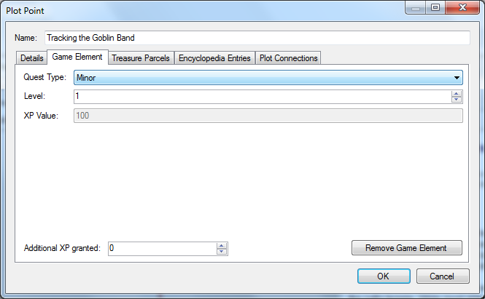

You can specify whether the quest is a major or minor quest, and specify the quest level (this defaults to the party level). The XP value of the quest will be automatically updated.

## Maps

You can also add maps to plot points. Once a map has been created (see the section on Tactical Maps) it can be added to a plot point by clicking the **Map** button on the **Game Elements** page.

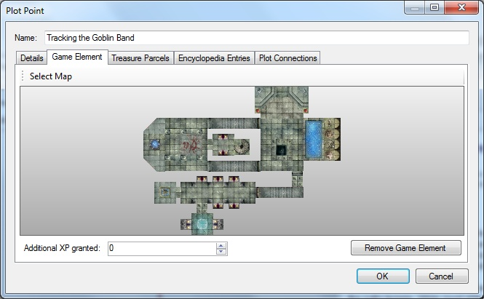

You can now select the map to be associated with this plot point.

# Campaign Background

You can set background information for your project using the **Background** tab.

The default background items are Introduction, Adventure Background, Adventure Synopsis, DM Information, Player Introduction and Character Hooks; you can add and remove items as you see fit, and items can be re-ordered using the **Move Up** and **Move Down** buttons on the toolbar.

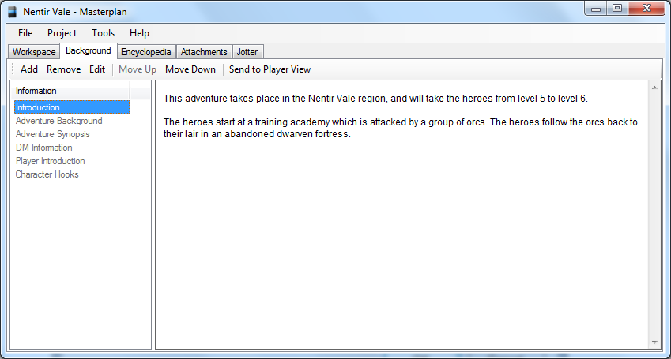

When you create a new background item, or edit an existing one, you will see the following screen. You can use HTML or Markdown in background item details.

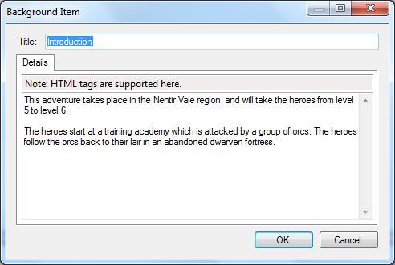

# The Encyclopedia

When running a long-term campaign, you will often want to note down general information about NPCs encountered, towns and cities visited, etc. The Encyclopedia tab enables you to do this from within Masterplan.

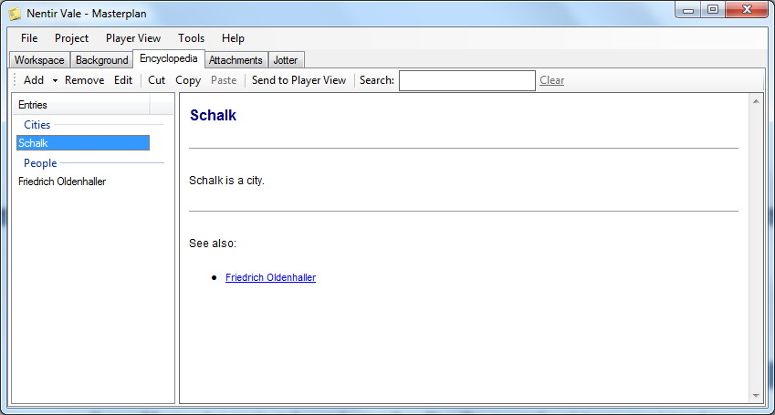

## Adding Entries

To create an encyclopedia entry, press **Add** on the toolbar. You can now enter information about the entry (including pictures, DM-specific information, and links between this and other existing entries).

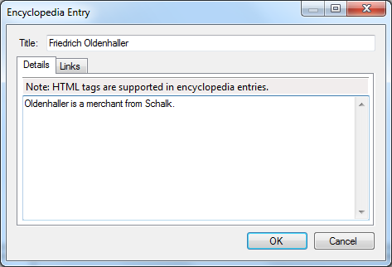

There are two ways in which you can use more advanced formatting in encyclopedia entry details:

* You can use HTML or Markdown.
* You can surround an entry name with double square brackets (using the syntax ‘[[entry_name|display_text]]’) to create a link to that entry; links to missing entries will be displayed in red.

Encyclopedia entries can also be created quickly in the following ways:

* For a PC (from the list of PCs) or for an NPC or a custom creature; the encyclopedia entry will contain the stat block.
* For a regional map location (from the regional map); the entry will contain a link to show the location on the map.
* For a rules item on the Rules tab; the entry will contain the item’s write-up.

## DM Information

Not all information in an encyclopedia entry will be information you want your players to have; Masterplan provides two ways to incorporate DM-only information:

* An entry’s DM-only information can be added to the **DM Information** tab.
* In the **Public Information** tab you can surround DM-only information with [[DM]] ... [[DM]] tags; anything within the tags is treated as DM information and will be displayed in bold.

## Groups

In addition to entries you can also create groups by selecting **Add Group** underneath **Add** on the toolbar. Groups allow you to view collections of entries simultaneously.

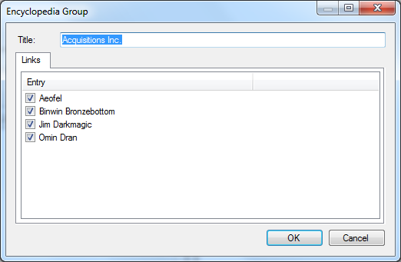

## Encyclopedia Entry Templates

You can define templates for your encyclopedia entries by saving them as HTML files and putting them in a folder named **Encyclopedia** in the main Masterplan folder. These templates are then available from the **Add** button on the Encyclopedia toolbar.

## Using the Encyclopedia

You can link to encyclopedia entries from within plot points by opening the plot point window and selecting the **Encyclopedia Entries** page.

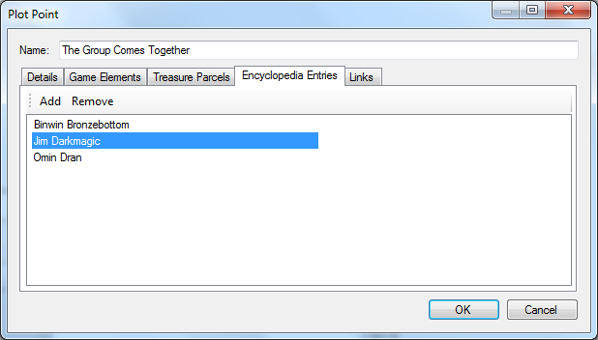

You can create a campaign bible by selecting **Publish** from the toolbar. This will bring up the **Handout** screen, and automatically add all encyclopedia entries to the handout. DM information is not included in the handout by default; you can change this by toggling the **DM Info** button on the toolbar.

If you want to share your encyclopedia with other projects, select **Export** from the toolbar to save your encyclopedia entries. To import this encyclopedia file into another project, select **Import** from the toolbar.

# Campaign Rules

Masterplan allows you to define homebrew rules elements (such as races, classes, paragon paths, epic destinies etc) for use in your campaign.

Each of these elements has its own designer and can be exported as a handout for your players.

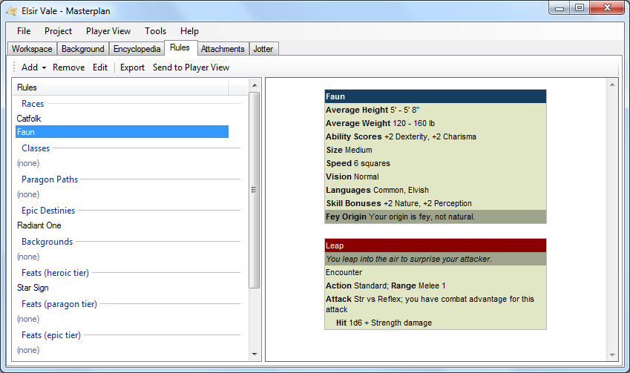

Rules items can be shared between projects by selecting **Export** or **Import** from the **Share** menu.

# Attachments

If your Masterplan project depends on other files (for example, pictures you intend to use as player handouts) you can add these files into your project.

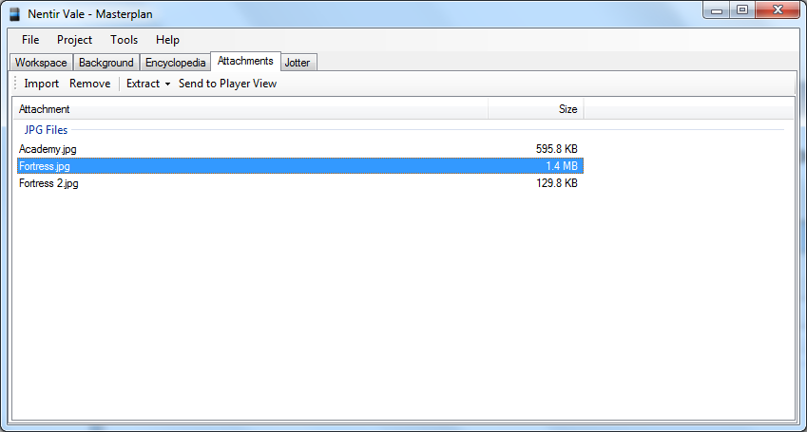

You can import a file into your project either by pressing the **Import** button on the toolbar or by dragging and dropping a file onto the list. If you already have an attachment with this name in the project, you will be asked whether you want to replace the existing attachment or add the new one with a new name.

You can open the file by selecting **Extract to Desktop and Run** from the **Extract** menu on the toolbar. This extracts the file to your desktop and opens it with the default application. If you do not want to open the file (or you want to open it with a different application) select **Extract to Desktop** instead.

# The Jotter

As you create your campaign you may need to write notes to yourself; this can be done using the **Jotter** tab. To create a new note, click **Add Note** on the toolbar and type your note directly into the application.

This tab will also contain warnings about the project (for example, encounters and skill challenges which are too easy or too difficult; projects which do not include enough treasure parcels; skill challenges which have no skills defined).

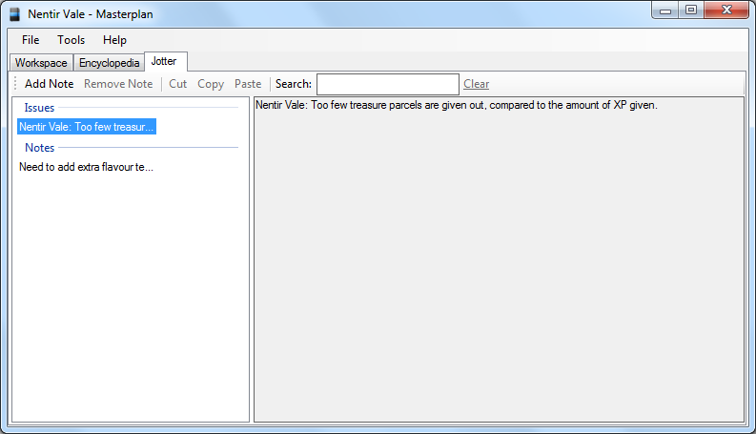

# In-Session Reference

This page provides a quick reference which holds useful information for your gaming sessions.

## Party Breakdown

The party breakdown section shows you the essential statistics for your players’ characters, including the range of their defences, their passive perception and insight, and the languages they understand.

You can click on various fields in the breakdown to see a more detailed breakdown of that field.

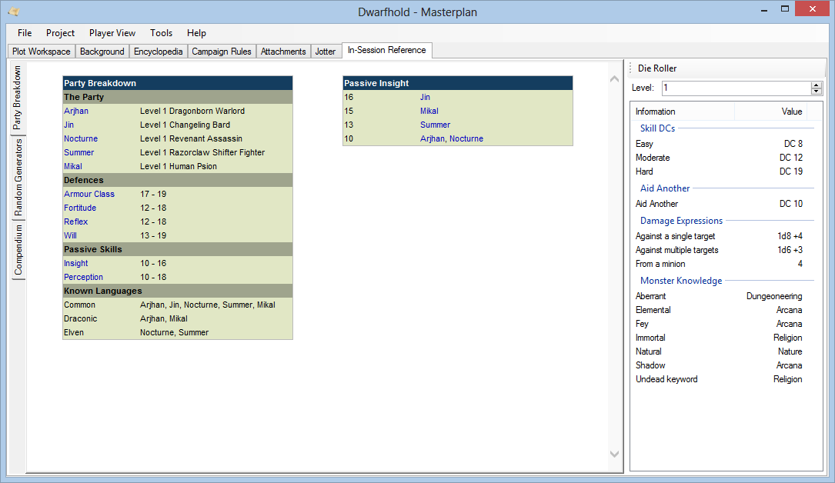

## Random Generators

This section provides a collection of random generators, such as names, potion descriptions, room descriptions, foreign text, etc.

# Tactical Maps

Your project can contain a set of tactical maps, such as dungeons or castle keeps. Select **Tactical Maps** from the **Project** menu to see them. From here you can create new maps using the **Add** button, which brings up the Map Editor. You can also print your maps or save them as image files.

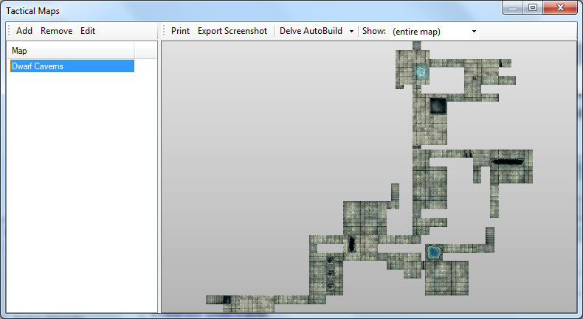

## Map Editor

The map editor allows you to build maps by dragging tiles from the right-hand list and dropping them onto the grid.

You can press the **Filter This List** button to narrow down your list of tiles by library or keyword.

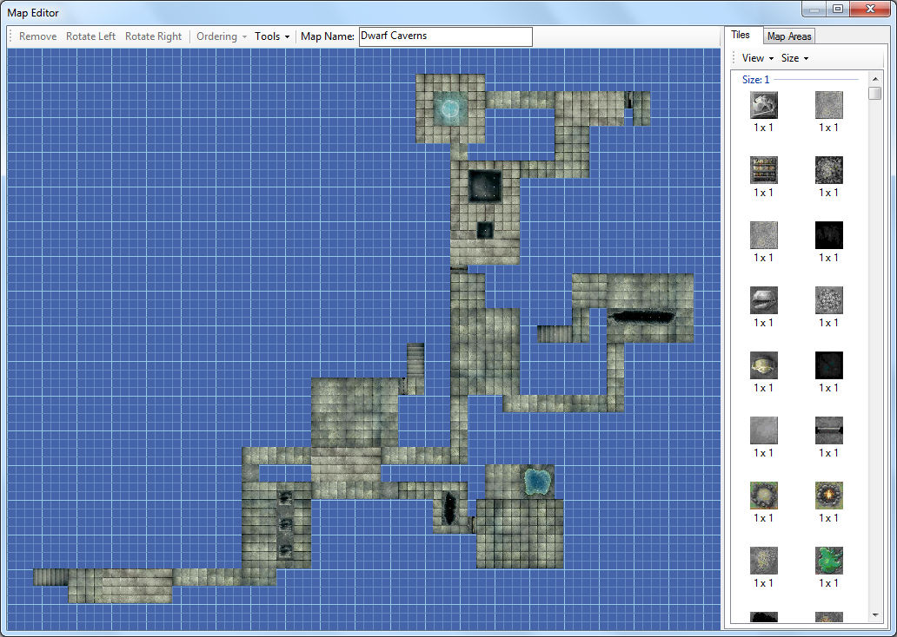

### Editing the Map

You can reposition a selected tile by dragging it (or using the keyboard arrow keys) or change its orientation by selecting **Rotate Left** or **Rotate Right** from the toolbar (or by holding shift and using the keyboard arrow keys). You can remove a tile from the map by selecting it and pressing **Remove** on the toolbar or pressing the Delete key.

You can select multiple tiles by holding the Control or Shift keys while selecting tiles, or by right-clicking and dragging to select a region and selecting Select Tiles from the menu that appears. You can then move, rotate or remove all the selected tiles as a group.

You can also right-click on a tile and select Swap Tile; this will bring up a list of all the other tiles of that size; double-clicking on one of these tiles adds this tile in place of the original.

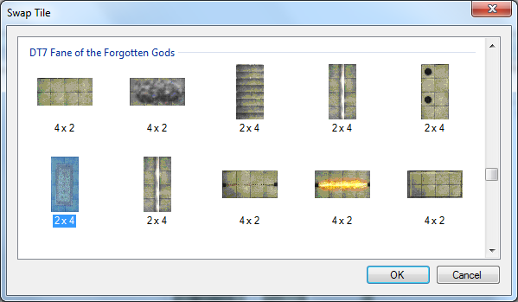

### Scroll and Zoom

You can scroll around and zoom in and out of the map by selecting **Scroll and Zoom** from the Tools menu. When this is selected, click and drag with the mouse to scroll, and use the slider to zoom. In this mode you cannot edit the map; to stop scrolling and zooming, select Scroll and Zoom again. To return the map to its initial state, select **Reset View** from the Tools menu.

### Map Areas

You can specify map areas (rooms etc) by right-clicking and dragging to select a region of the map. Select the **Create Map Area** option from the menu that appears. This allows you to name the area, and enter any additional details about it (such as illumination, room features, and so on).

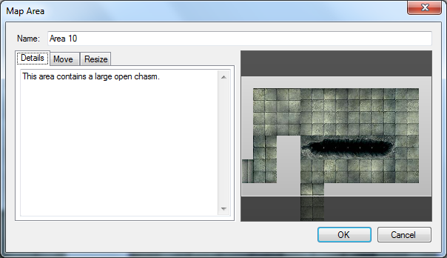

You can change the map area by using the **Move** and **Edit** pages.

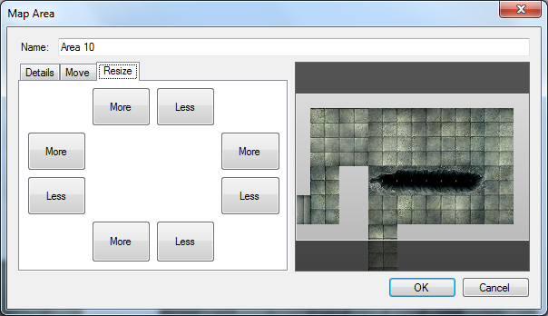

The new area will appear in the **Map Area** list. When you select an area from the list, the view will zoom to that area. When no area is selected, the view will zoom out to show the entire map.

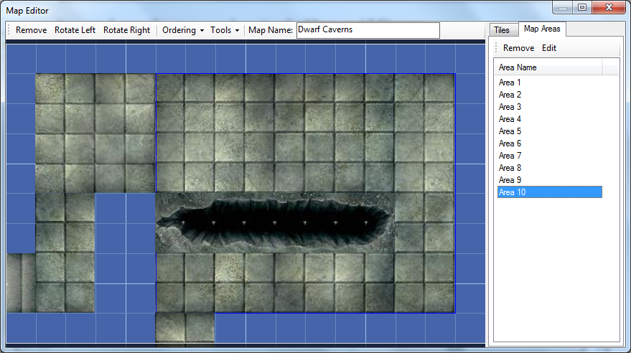

### Map AutoBuild

As for encounters, Masterplan provides an **AutoBuild** feature for maps. This feature is available from the map editor’s **Tools** menu.

When accessed, you are asked whether you want to create a dungeon map or a randomly filled rectangular area, and then specify which libraries to use when building the map. If you have a library which is not shown in the list, it may be because you have not specified the categories for its tiles. In the main screen select **Libraries** from the **Tools** menu and edit the tiles.

For a dungeon map you can also specify the maximum and minimum number of areas you want your map to consist of, and the map will be built according to the categories of the tiles:

* **Plain**: These tiles will be used to create rooms and corridors
* **Doorway**: these tiles will be used to create doorways into rooms and in corridors
* **Stairway**: these tiles will be used to end corridors
* **Feature**: these tiles will be added to rooms after they are created
* **Special** or **Map**: these tiles are not used

For an area map you are asked to specify the dimensions of the area.

### Using a Background Map

If you want to extend an existing map, for example to add a new level to an existing dungeon, you can do this by selecting **Select Background Map** on the **Tools** menu. The map you select will be shown as a ghost behind the map being edited.

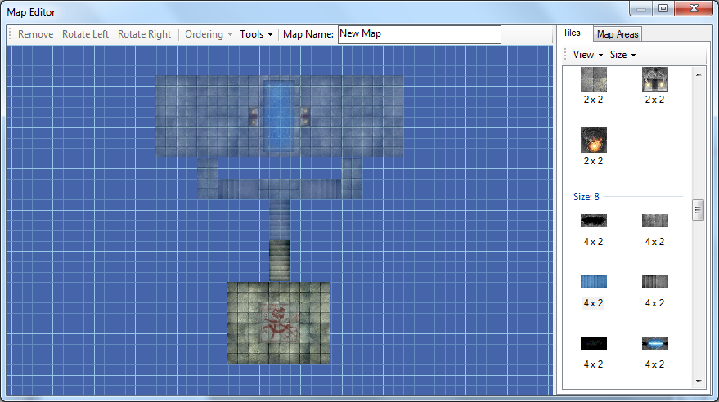

If a background map is visible you can remove it by selecting **Clear Background Map** on the **Tools** menu.

## Using Maps With Encounters

To associate an encounter with a map area, open the encounter builder and turn to the **Encounter Map** page. Press the **Select Map** button on the toolbar to choose the map which the encounter will use; the view will show the selected map area.

A list will appear at the right showing the creatures in that encounter. Drag and drop each creature onto the map; when all the creatures have been added to the map, the creature list will disappear.

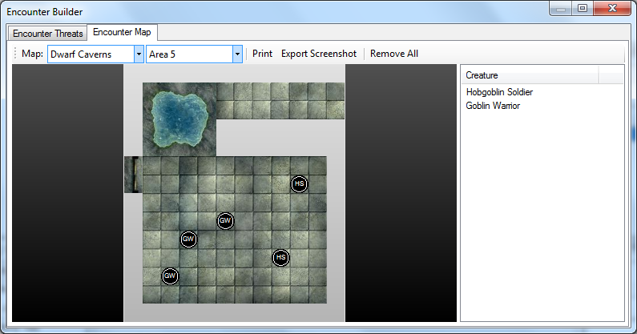

You can move creatures around the map by dragging them, but you cannot drag a creature off the map or onto another creature. If you move the mouse pointer over a creature, a tooltip will display its statistics.

### Custom Map Tokens and Overlays

You can add custom tokens to represent miscellaneous encounter features or mounts for other creatures, whereas custom overlays can be used to represent unusual terrain, area effects or map tiles.

Select **Add Custom Token** or **Add Custom Overlay** from the **Map Tokens** menu.

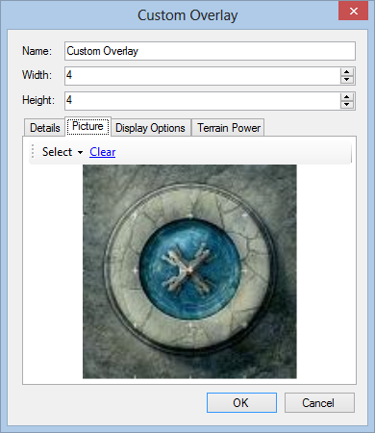

Once placed on the map, the token or overlay can be moved around like other tokens, except that overlays can be moved off tiles and over other tokens.

Overlays are always shown underneath other tokens, so they never get in the way when you are moving creatures or PCs around the map. Overlays have two display styles which you can select: **Rounded**, in which the overlay is translucent with rounded edges, and **Block**, in which it is rectangular and opaque.

Custom tokens and overlays can include a terrain power, which can be created or selected from your libraries.

## Printing

You can print a map from the Tactical Maps screen by selecting **Print Map** from the **Print** menu. You are then presented with two options:

* Print the entire map on one page; the map will be rotated and scaled to make the best use of the page area.
* Print the map at a scale of 1” to a map square (to create poster-style maps).

This screen also gives you the option to print sheets of blank 1” grid; to do this, select **Print Blank Grid** from the **Print** menu.

## Delve AutoBuild

The Tactical Maps screen provides a Delve AutoBuild option for any maps which contain at least one area. This creates a randomly-generated encounter for each map area and placing creatures on the map. It also randomly assigns treasure parcels. With this option you can also use an encounter deck to build the encounters.

## Tile Breakdown

If you want to see how many tiles from each library make up a map, select it in the Tactical Maps screen and select **Tile Breakdown** from the **Tools** menu (this is particularly useful if you have sorted the map tiles into libraries based on which Dungeon Tiles set they come from).

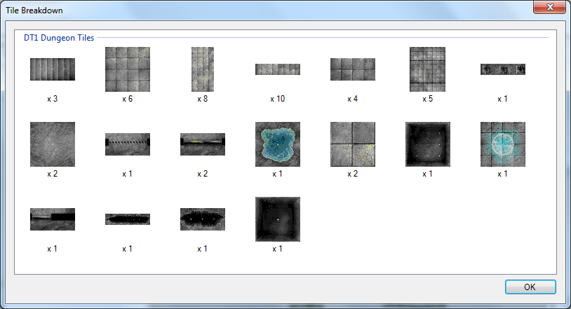

# Regional Maps

Your project can contain regional maps (for example, maps of continents or cities). Select **Regional Maps** from the **Project** menu to see them.

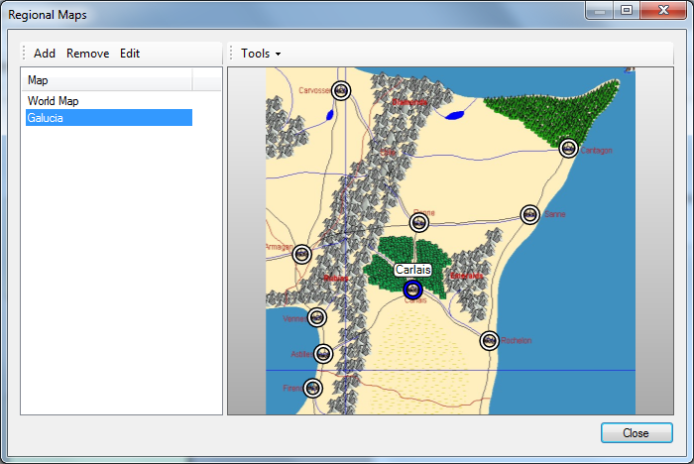

To create a new regional map, select **Add**. You can then name your map and select an image to be used for the map.

You can also add locations to your map. Locations can be associated with a category (for example, a city map might have an **Inn** location, whereas a world map might have **Mountain** locations.

# Player Characters

You can enter information about the PCs by selecting **Player Characters** from the **Project** menu.

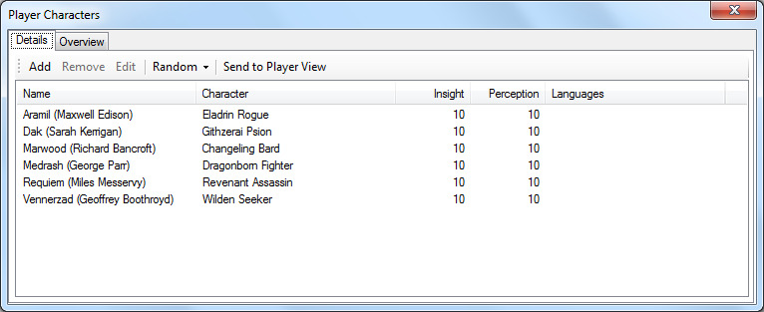

To add a new PC, click the **Add** button on the toolbar. You can now enter the character name, player name, and information on the character’s race and class. You can also add the character’s combat stats, passive insight and perception scores, languages, and select a portrait for the character.

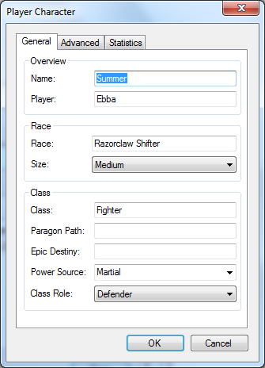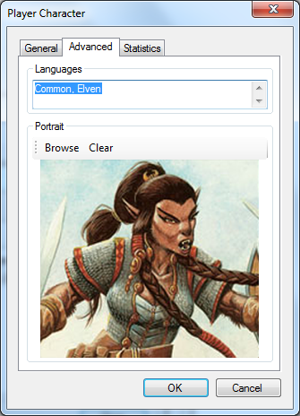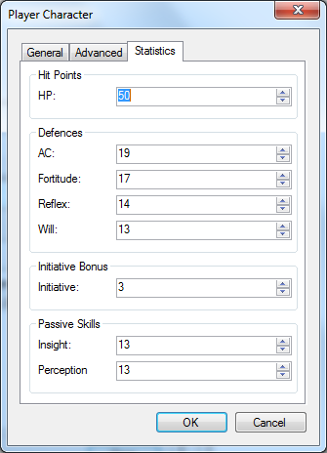

To speed up combat, you can predefine effects (such as ongoing damage or status effects), map tokens and map overlay tiles for each PC. To do this, switch to the Combat page and press the **Add** button.

You can also import a character file from the Character Builder by selecting **Import from Character Builder** under the **Add** button (if a previous version of this PC has already been entered, its stats will be updated).

You can also import a character (or all the characters in a campaign) from iPlay4e. Select **Import iPlay4e Character** or **Import iPlay4e Campaign** under the **Add** button and enter the key (remember that for characters to be imported they must be marked as *public* on the iPlay4e website). If you have at least one iPlay4e character in your project, a button will appear to allow you to automatically refresh their statistics from the server.

You can also use the **Suggest a PC** option, from the **Add** menu, to get Masterplan to suggest a class / race combination which might fill a role that the current party is lacking.

PCs can be set as active or inactive by selecting the PC and pressing the **Active** button on the toolbar. This might be useful if, for example, a certain player will be unable to attend a session.

Selecting the **Overview** tab shows the breakdown of role and power source of the party.

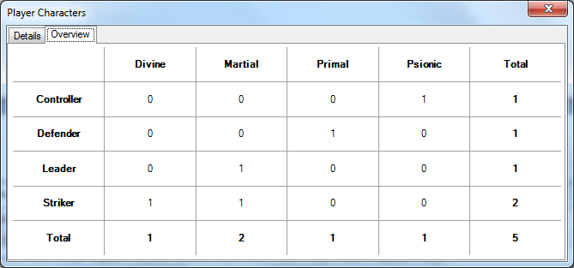

# Treasure Parcels

Plot points can contain treasure parcels. To add treasure parcels to a plot point, you first need to define the available parcels for your project. To do this, select **Treasure Parcels** from the **Project** menu.

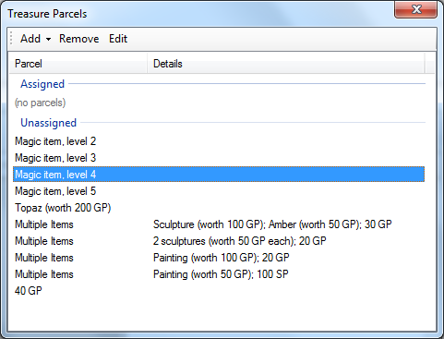

When you create your project, a random set of 10 level-appropriate treasure parcels are created for you automatically.

You can add a set of parcels by selecting **Add Standard Set** from the **Add** menu on the toolbar – you can edit their details or remove them from the list with the **Edit** and **Remove** toolbar buttons. You can also add individual custom items by selecting **Add Parcel** from the **Add** menu.

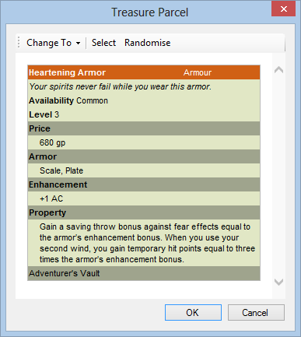

It’s also possible to specify which PCs are given each parcel (for example, if you want to check that each character receives a comparable amount of treasure). You can do this from the plot point treasure parcel page, or from the treasure parcels screen.

To add treasure parcels from this list to a plot point, double-click on the point and turn to the **Treasure Parcels** page.

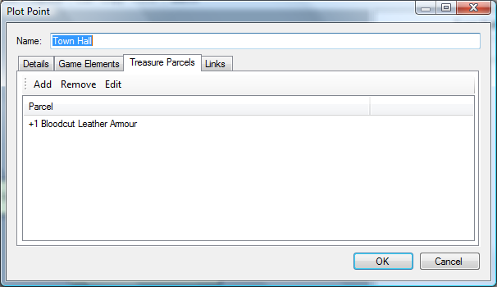

You add a treasure parcel by pressing the **Add** button on the toolbar. This allows you to add a treasure parcel (either a predefined one or a new custom one), or select a magic item or artifact.

If you want to remove a treasure parcel from a plot point, select the parcel and press the **Remove** button on the toolbar. This will move the parcel back into the list of unassigned parcels.

## Creating Magic Item Handouts

You may find that you need to print out a reference sheet of magic items that you intend to give out to the PCs; to do this in Masterplan select **Export Treasure List** from the **Tools** menu to bring up the Treasure List screen – you can also access this screen by selecting **Export Treasure List** from the **Advanced** button on the Workspace page.

On this screen you can select the magic items that you want to export; optionally, if you are using subplots to organise your campaign, you can select a subplot to show only the magic items that are available in this subplot.

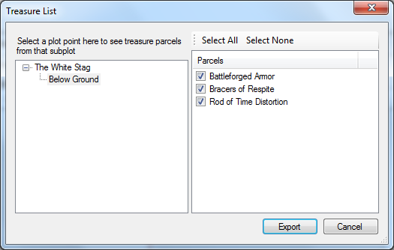

When you press **Export**, an HTML file will be created which contains the magic items in a 3x3 grid, which you can then print out and give to your players as they obtain them.

# Running Combat Encounters

To run the combat encounter associated with a plot point, open the plot point and press the **Run** button on the **Game Elements** tab. Alternatively, if the encounter has a map, it will be shown in the preview pane when the plot point is selected in the workspace; double-click on it to run the encounter.

The combat view shows a list of combatants on the left. If the encounter includes traps or skill challenges these are included in the combat list.

If the encounter has a map associated with it, it will be shown with the opponents displayed as black tokens, whereas PCs are shown in green. PCs (and any creatures which are not on the map at the beginning of the combat) can be dragged from the list onto the map.

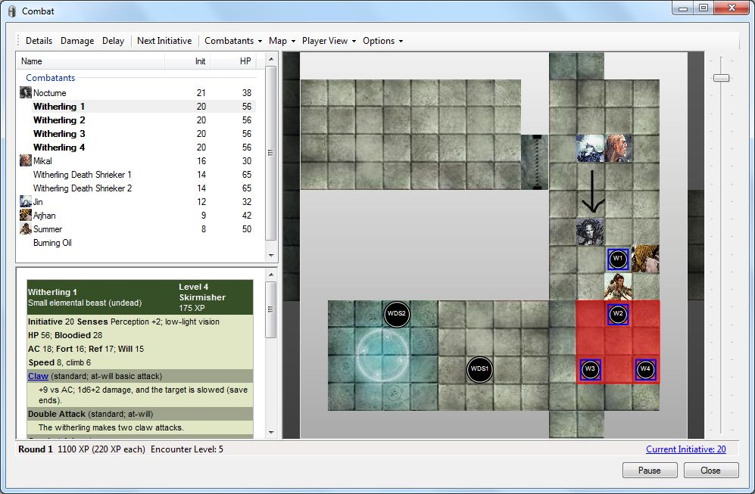

To quickly determine which map token represents which creature in the list, select the creature in the list; the appropriate map token will be temporarily highlighted with a red outline.

## Starting a Combat Encounter

When the combat view appears, you will see the following set of options.

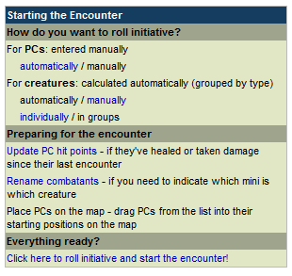

The first section allows you to specify how you want to roll initiative – by default Masterplan assumes you want to enter the initiative scores rolled by your players, but it will roll initiative for the creatures and traps in the encounter.

The middle section allows you to do a few common combat-related admin tasks.

If you click on the **Update PC hit points option**, a screen appears where you can specify how many hit points each PC begins the encounter with.

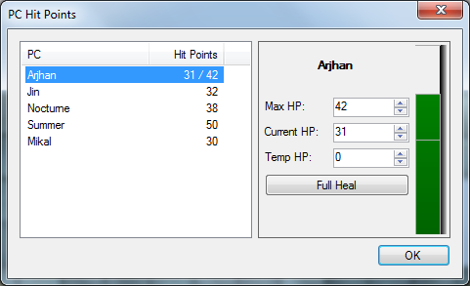

If you click on the **Rename combatants** option, you are taken to a screen in which you can change creature display names – this can be useful if you are using miniatures and need a way to distinguish between them.

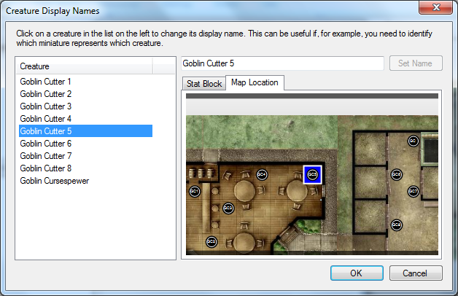

Finally, the link at the bottom begins the encounter. If you have opted to roll initiative manually you will be prompted to enter the results before the encounter begins.

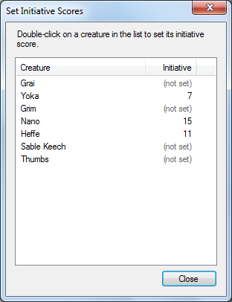

## Moving Down the Initiative Order

The slider at the right of the screen shows the current initiative score. When it is a combatant’s turn they will be shown in bold in the list; on the map they are highlighted with a blue outline. You can click the **Next Turn** button on the toolbar to automatically advance the current initiative score to that of the next creature or PC. When you do this, Masterplan may prompt you about some combat-related housekeeping tasks before you regain control of the combat.

If the creature or PC whose turn is now over is subject to ongoing conditions or damage, you will be prompted to roll saving throws for them. Masterplan will automatically remove the conditions which the creature saves against.

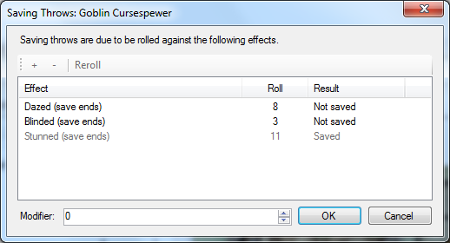

Some ongoing effects may last until the start or the end of a creature’s turn. You will be informed if any such effects have ended; you will have the option to extend them for another round.

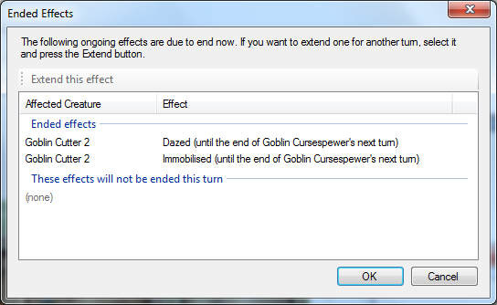

If the creature or PC whose turn is beginning is wounded and has regeneration, you will be informed about this.

If the creature or PC whose turn is beginning is subject to ongoing damage, you will be prompted to apply that damage. Masterplan will take into account any damage resistances, vulnerabilities and immunities the creature may have.

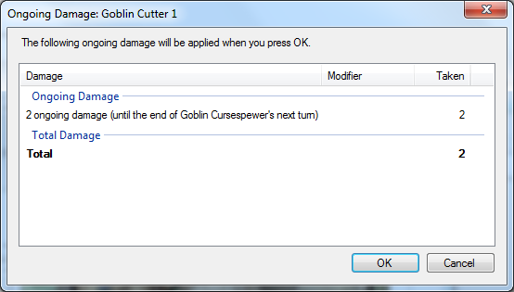

If the creature whose turn has now begun can recharge their encounter powers, you will be prompted to do this. If the power recharges on a D6, this will be rolled for you automatically.

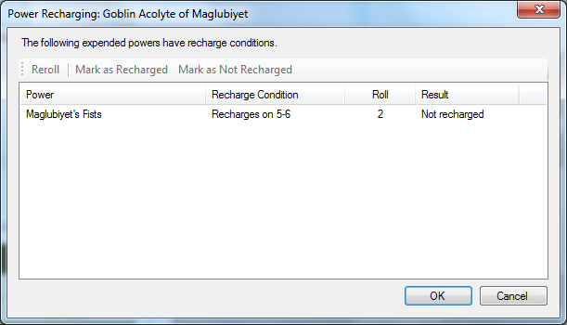

## Creature Powers

You can use a creature’s powers by selecting the creature (either in the list or on the map) and clicking on the name of the power.

* If the power has been defined with an attack roll, this will be rolled for you automatically.
* If the power is a limited use power (i.e. a per-encounter power, or a rechargeable power), Masterplan will offer to mark it as expended.

Right-clicking on a creature (in the list or on the map) and selecting **Details**, double-clicking on a creature in the list, or clicking the **Details** button on the toolbar when a creature is selected, allows you to edit its hit points and initiative score. You can also set the creature’s altitude (in squares).

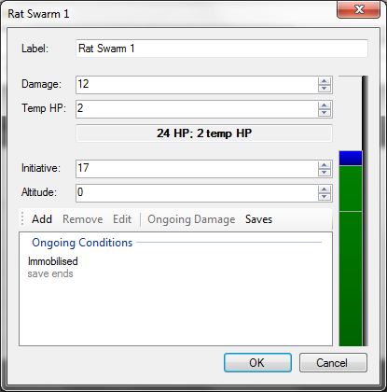

On the right hand side of this dialog there is a gauge showing the combatant’s current hit points (including temporary hit points, if any, in blue). This gauge will turn red when the combatant is bloodied.

You can also use this screen to add ongoing conditions or damage by pressing the **Add** button.

## Damage and Healing

You can mark damage on a creature in any of the following ways:

* Right-clicking on a creature (in the list or on the map) and selecting **Damage**
* Double-clicking on a creature on the map
* Clicking the **Damage** button on the toolbar when a creature is selected
* Clicking on a creature’s HP in its stat block

This will bring up the damage screen, which allows you to quickly deal damage to the selected creature. You can specify the type of damage that is being dealt; if the creature has resistance, vulnerability or immunity to that damage type, this will be taken into account. When you press OK the damage will be applied to the creature; the damage will be taken from the creature’s temporary hit points first, if it has any.

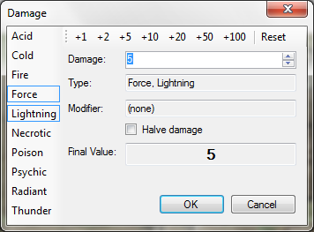

Similarly, you can heal creatures by selecting Heal from the toolbar, or from the right-click menu.

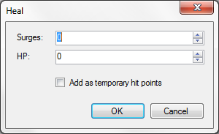

When opponents are bloodied, they are displayed (in the list and on the map) in a dark red colour. When they are killed, they are automatically removed from the combat; you can disable this feature by deselecting **Remove Defeated Opponents** on the **Options** menu, in which case dead creatures will be displayed in light gray.

## Ongoing Effects

You can apply ongoing effects to a creature in any of the following ways:

* Right-clicking on the creature in the list or on the map
* Selecting **Add Effect** from the toolbar when a creature is selected

You will be given the option to apply a predefined effect, or to create a new effect.

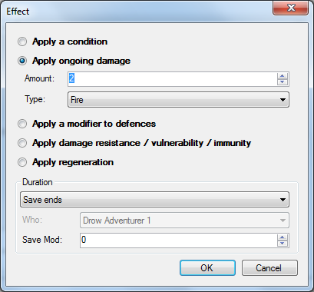

When you add a new effect, Masterplan will ask whether this has been applied by a PC; if it has, the effect will be added to that PC’s repertoire and you will not have to define it again – it will be available from the list automatically for all future encounters. Otherwise the effect will be added to the list for this encounter only.

If a creature is subject to any ongoing effects, this will be shown as a red badge on its map token.

## Drawing on the Map

You may find yourself wanting to point out a particular dungeon feature, or indicate a plan of attack; Masterplan allows you to do this by drawing directly onto the combat map. To activate this feature, select **Allow Drawing** from the **Map** menu (selecting it again turns the feature off again). Anything you draw on the DM map will be replicated on the player view map and vice-versa).

You can clear the map’s current drawings by selecting **Clear Drawings** on the **Map** menu.

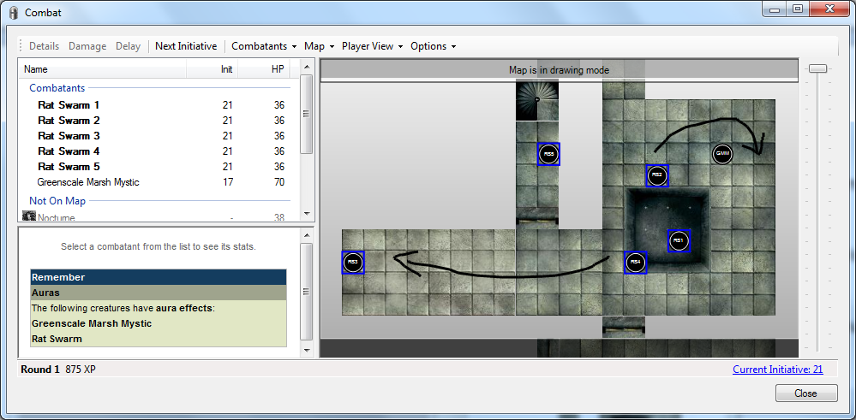

## Links between Map Tokens

If you drag one map token onto another, you can create a visible link between the tokens. This can be useful for noting marks and curses, for example.

Dragging the tokens together a second time will clear the link.

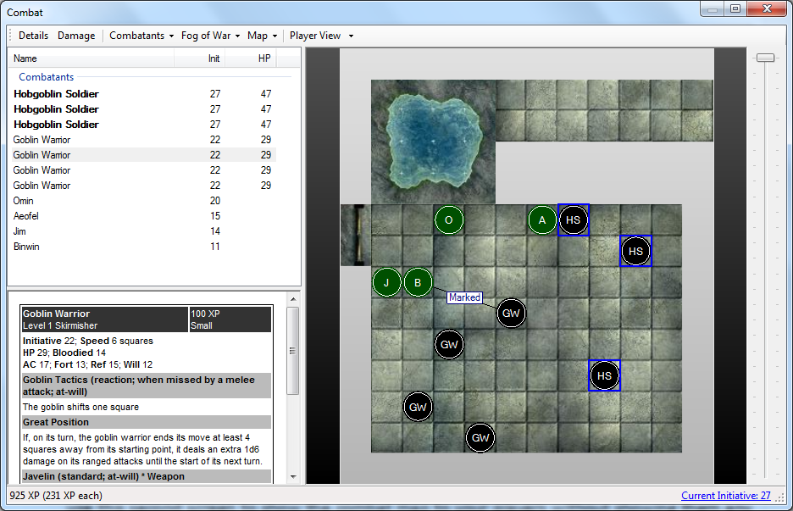

## Line of Sight

In order to determine whether a PC or creature has line of sight to another square, you can use the Line of Sight feature; to enable this feature, right-click on the map and select **Line of Sight**. Lines will be drawn on the map from each selected token to the closest corner of the square the mouse is currently hovering over; this will enable you to see whether the token has line of sight to this square.

To disable this feature and return to normal, double-click on the map.

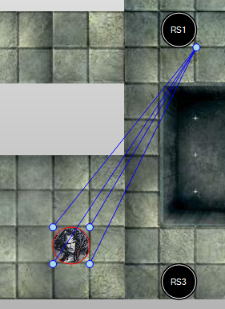

## Adding Creatures During Combat

You can add new creatures / NPCs / traps / skill challenges to an encounter on-the-fly by selecting **Add** from the **Combatants** menu. The standard screen for creating encounters will appear; when you close it your encounter will be updated automatically.

If you’ve set up your encounter to include multiple waves, you can add waves into the encounter from the **Combatants** menu.

## Adding Custom Tokens and Overlays

You can quickly add a custom token or an overlay to your encounter by dragging it from the **Tokens and Overlays** tab onto your map.

## The Encounter Log

Masterplan maintains a brief history of every encounter which you can find on the **Encounter Log** tab. A shorter version of this log will be displayed on the player view initiative list.

## The Encounter Report

You can see a breakdown of the encounter by pressing the **Report** button at the bottom left of the screen. This report can show various statistics, such as the time taken or the damage done, per round. You can show this data for each combatant, or group them by controller or by faction.

The report also calculates the MVP (most valuable player); this is displayed in the toolbar.

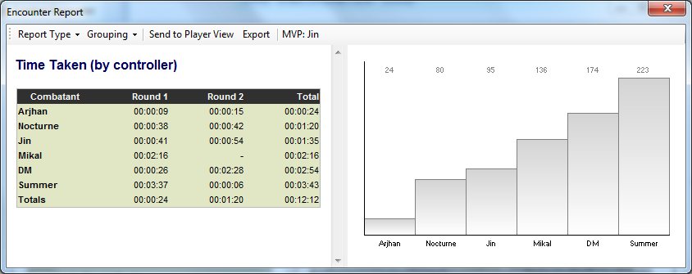

## Layout

If you are running Masterplan on a typical computer, the combat screen will be displayed in landscape mode – that is, with the list of combatants on the left, and the encounter map on the right. If instead you have a tablet or a slate, the combat screen will be shown in portrait mode – that is, with the encounter map below the combatant information. This default state can be overridden by selecting **Landscape** or **Portrait** from the **Options** menu.

You can change the layout of the combat window to suit your preferences by using items on the **Options** menu:

* **One Column** or **Two Columns**: specifies whether the combatant information is displayed in a single column or in two columns.
* **Map at Right** or **Map Below**: specifies whether the combat map, if one exists, is displayed on the right-hand-side or at the bottom of the window.

In addition, you can change the columns which are visible in the list by selecting Columns from the Options menu. The available columns are:

* **Initiative**, which shows the combatant’s initiative score
* **Hit Points**, which shows the combatants current and total hit points, and any temporary hit points
* **Defences**, which shows a creature’s defence scores
* **Effects**, which lists any ongoing effects the creature or PC is affected by

## Ending an Encounter

To end the encounter, press the **End Encounter** button.

If you would like to pause the encounter and resume it at a later data, press the **Pause Encounter** button. You can resume the encounter by selecting **Paused Encounters** from the **Project** menu.

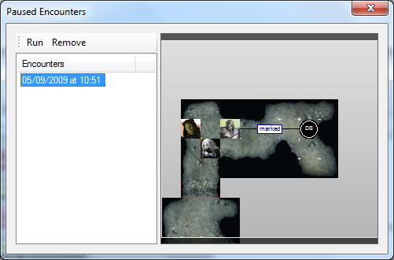

# Using the Player View

If you are using Masterplan to run a game, you will often want to show certain information to your players. You can use the Player View feature to show various items to your players without showing them any other information.

Use the **Show** command on the **Player View** menu to display or hide the player view. You can clear the current contents of the player view at any time by selecting **Clear** from the **Player View** menu.

By default the player view will be displayed on a secondary display (such as a second monitor, a television or a projector), if one is available and connected. You can override this by deselecting **Show on Other Display** from the **Player View** menu.

**Plot points**: When you have a plot point selected, you can use the **Send to Player View** option from the **Share** menu on the right-hand-side to show the point’s read-aloud text on the player view screen.

**Background items**: When you have a background item selected, you can use the **Send to Player View** button on the toolbar to show the item on the player view screen.

**Encyclopedia**: When you have an encyclopedia entry selected, you can use the **Send to Player View** button on the toolbar to show the text of the entry on the player view screen. The links to other encyclopedia entries are not shown.

**Attachments**: When you have an attachment selected, you can use the **Send to Player View** button on the toolbar to show the attachment contents on the player view screen. This feature is only available for certain file types (plain text files, rich text files, image files, URL links, and HTML web pages).

**The party**: In the player characters screen, press the **Send to Player View** toolbar button to send the list of PCs to the player view screen.

**Handouts**: In the Export Handout screen, when your handout contains at least one item, you can use the **Send to Player View** button on the toolbar to show the handout on the player view screen.

**Player options**: In the Player Options screen you can use the **Send to Player View** button on the toolbar to show the selected item on the player view screen.

**Calendars**: When a calendar is selected in the calendar list screen, you can select **Send to Player View** from the toolbar to show the selected calendar on the player view screen.

**Combat**: In the combat screen, select **Show Map** from the **Player View** menu (or **Show Initiative List** if there is no encounter map). This will bring up a copy of the current map on the player view screen. The map on the player view will be identical to the main combat map, except for the following differences:

* The initiative order is shown to the right of the map (this can be toggled on or off by selecting **Show Initiative List** on the **Player View** menu. Creatures which are invisible are not displayed on this list.
* The creature initials (as shown on the main combat map) are replaced with the initials of the creature’s category. This can be changed with the **Show Creature Labels** option on the **Player View** menu.
* Only visible creatures will be shown to the players; when a hidden creature is made visible it will automatically appear on the player view map. You can change this with the **Fog of War** option on the **Player View** menu.
* Tooltips for creatures will indicate their general health status (not wounded / wounded / bloodied / dead) rather than their stats.

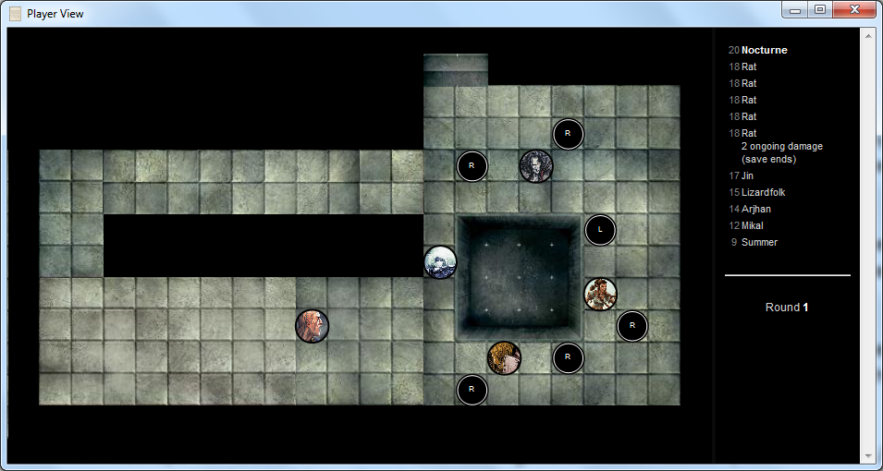

# Other Tools

## Project Overview

The **Project Overview** option, available from the **Project** menu, allows you to quickly see all the encounters, skill challenges and treasure parcels which are contained in your project.

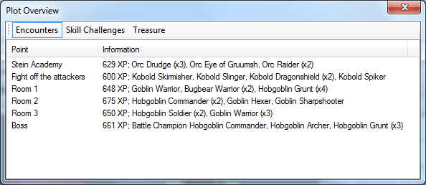

## Campaign Settings

If you want to run a campaign or an adventure at a higher or lower difficulty than it was designed for, select Campaign Settings from the Project menu.

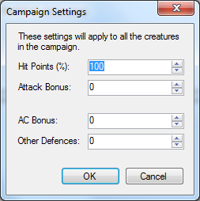

This feature allows you to modify creature hit points, attack bonuses and defences, without changing the creatures directly.

## Information Screen

The Information screen, available in the plot point screen, the encounter builder and when running encounters, shows a quick list of useful information.

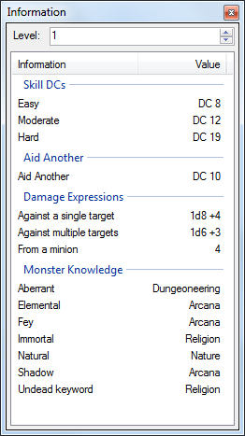

You can double-click the damage expressions to bring up a dice roller with those expressions pre-loaded.

## Custom Creatures and NPCs

To create custom creatures or NPCs for your campaign, select **Custom Creatures and NPCs** from the **Project** menu.

Note that these creatures and NPCs are stored in your project file, not in any libraries.

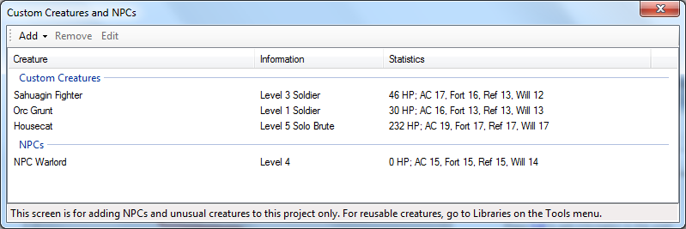

## Encounter Decks

You can create encounter decks with which to build encounters. Select the **Encounter Decks** option from the **Project** menu.

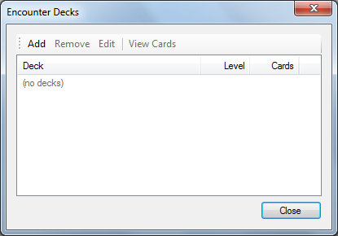

This shows the encounter decks in your project. To create a new deck, select **Add** from the toolbar; this will bring up the encounter deck builder.

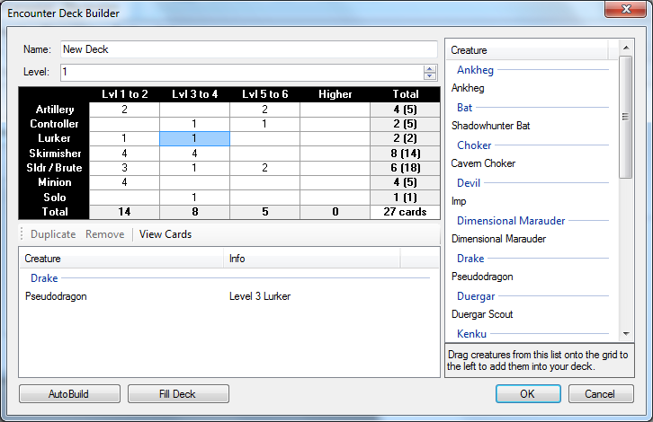

To build an encounter deck, select a cell in the grid. The right-hand list will then be filled with all the creatures that can be added to that cell. Dragging creatures from the list onto the grid will add them into the deck. The grid shows the current number of creatures in each row, and (in parentheses) the recommended number of creatures.

You can double-click on any cell in the table to see the creatures contained within it.

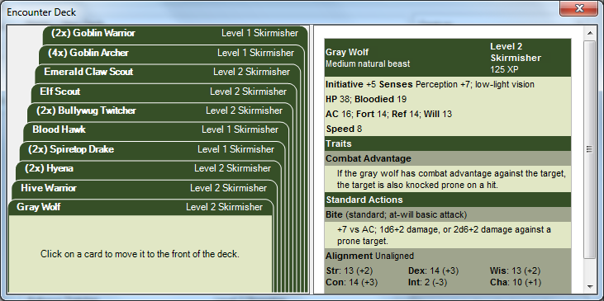

If you don’t want to specify every creature in the deck, you can ask Masterplan to create a deck for you. Press the **AutoBuild** button at the bottom left of the encounter deck builder; you can now specify the level the deck should be built for (this defaults to the party level) and the types of creatures that the deck can contain.

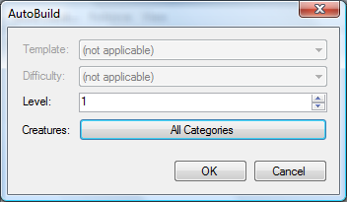

When you press OK the deck will be generated randomly, and the number of cards for each type of creature will be shown.

Once a card is drawn from a deck it won’t be used again until they are added back into the deck; you can do this by opening the deck builder and pressing the **Refill Deck** button. Drawn cards are shown in the deck builder in grey.

## Calendars

You can create custom calendars for use in your campaign by selecting the **Calendars** option from the **Project** menu.

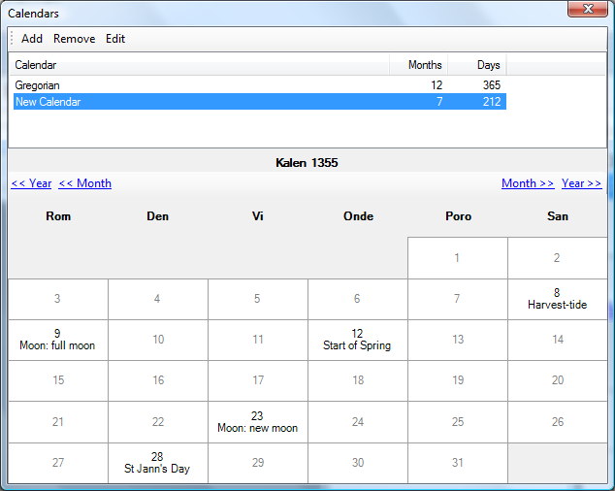

To create a new calendar, press the **Add** button on the toolbar. You can then enter the days and months of your new calendar, as well as giving it a name. You can specify that months have a different number of days during leap years, and how often leap years occur.

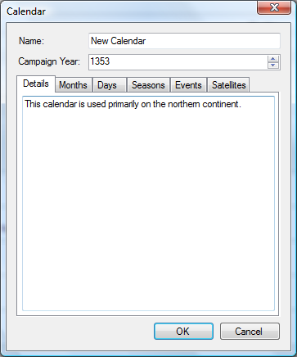

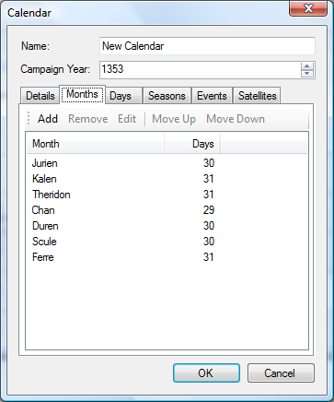

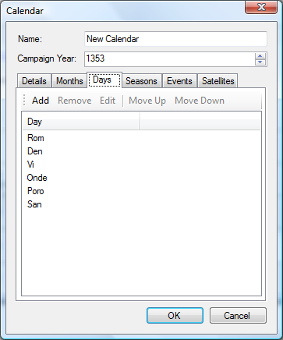

You can enter the dates when seasons begin, and other important dates for your calendar (such as anniversaries, holidays and the like).

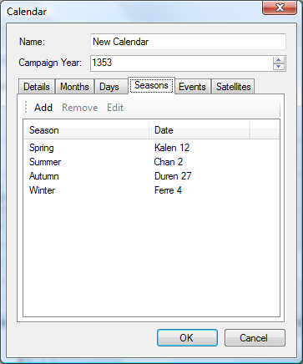

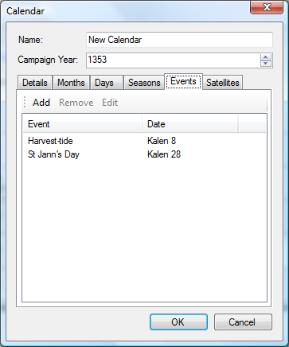

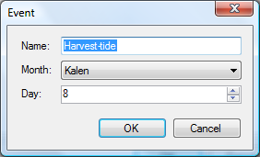

Masterplan will also keep track of the phases of any moons you enter.

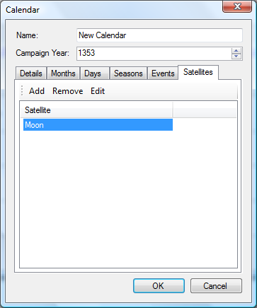

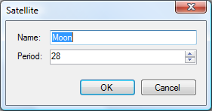

If you have at least one calendar in your project you can set the dates on which plot points occur. A toolbar will be visible on the plot point **Details** tab which allows you to set the date. When a date is set, an additional button will be visible which allows you to clear this date.

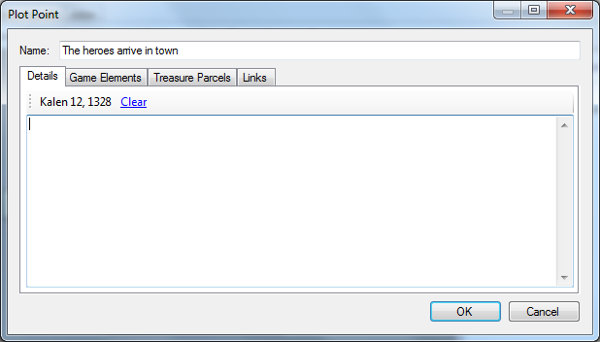

## Creature Builder

The creature builder is used any time you want to create a creature (a standard creature in a library or a custom creature in an encounter), or an NPC.

At the left of the screen you can see the creature being designed. On the right are some basic statistics about typical creatures of its level and role, and a list of powers from similar creatures – if you like these powers, you can quickly add them to your creature.

If you want to quickly adjust a creature’s difficulty, you can use the Level + / - buttons at the top right of the screen.

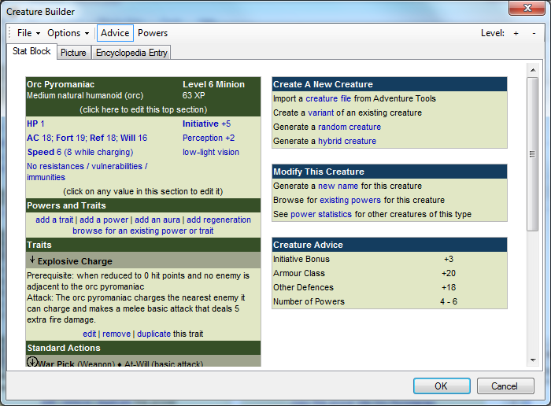

Clicking on the link in the top shaded section brings up the following screen:

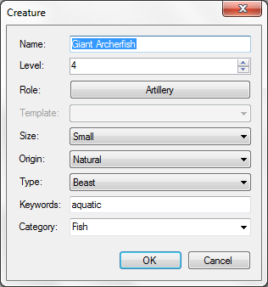

Clicking on any of the combat statistics will bring up the following screen:

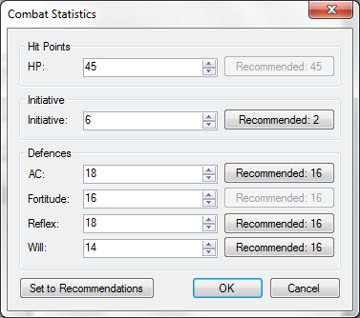

You can give your new creature resistances or vulnerabilities to certain damage types by clicking on the **Resistances / Vulnerabilities / Immunities** link.

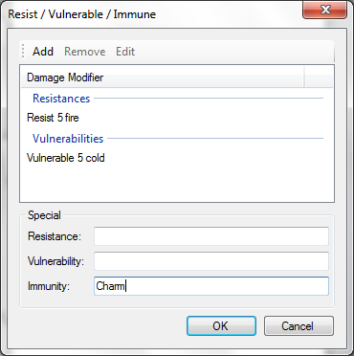

Here you can specify your creature’s damage modifiers (a damage modifier is a resistance, vulnerability or immunity).

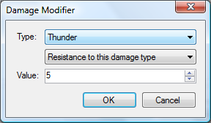

To enter a power or trait, click the **Add a Trait** or **Add a Power** link. This allows you to enter the new power’s details. The right-hand column shows you some typical power information for your creature’s type and level and gives some example power details that you can quickly copy into your power.

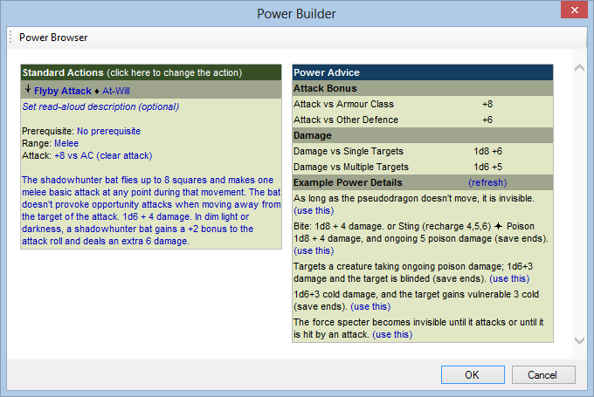

Another quick way to add powers to your creature is to switch to the Powers view by pressing Powers on the toolbar. This changes the right-hand sidebar to show a randomly selected set of powers from other similar creatures; you can copy them into your creature by clicking on the link.

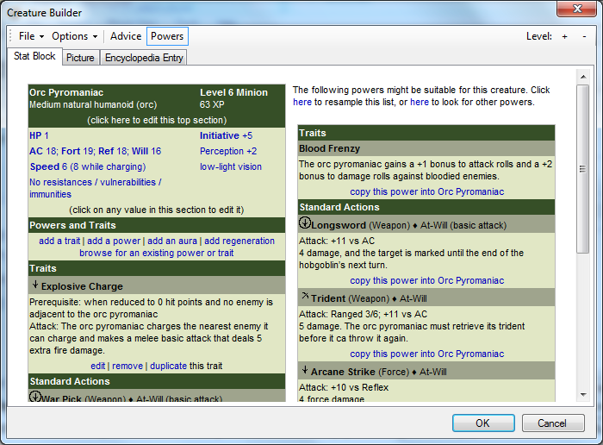

Alternatively, you can quickly import a power from another creature by pressing the **Browse for an Existing Power or Trait** link. This brings up a screen from which you can browse creature powers and import them into your creature by pressing the **Copy this Power Into…** link.

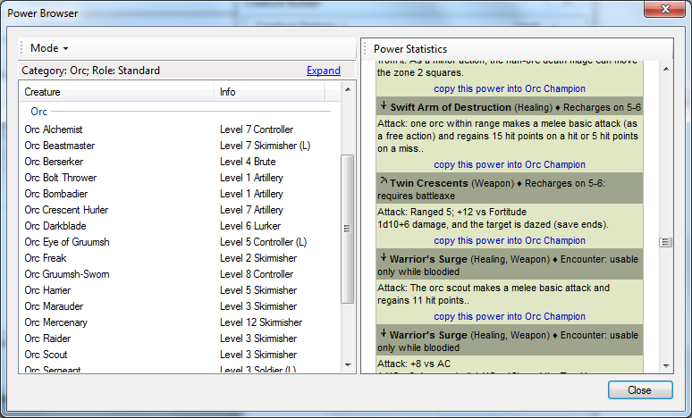

As in the encounter builder, you can press the **Expand** link to filter the list of creatures in various ways.

You can also set your creature’s regeneration details; press the **Add** **Regeneration** link.

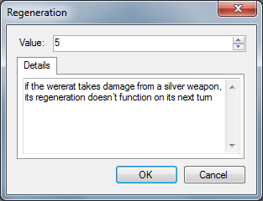

To modify your creature’s skills, slick the skills link.

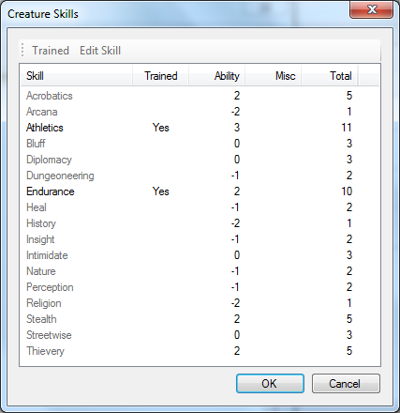

### Creating a Variant Creature

In addition to creating new creatures, you can modify existing creatures. To do this, select the **Create a variant of an existing creature** option. You will first be asked to pick the creature to modify.

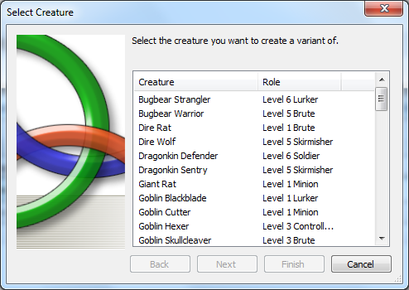

If the creature is not a minion, you then have the option of applying templates to it.

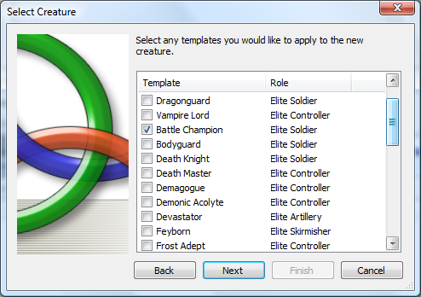

If the template(s) you have selected do not match the role of the creature you have selected, you will be asked to pick which role the modified creature will fill. Pressing Finish on the final screen will open the creature for editing.

### Creating a Hybrid Creature

To create a hybrid creature from two or more existing creatures, you can click the **Generate a hybrid creature** link. This brings up a screen in which you can select multiple creatures (either by double-clicking on them or by dragging them onto the bar at the top right). When you press OK, Masterplan will generate a creature that takes its stats and powers from the creature you selected.

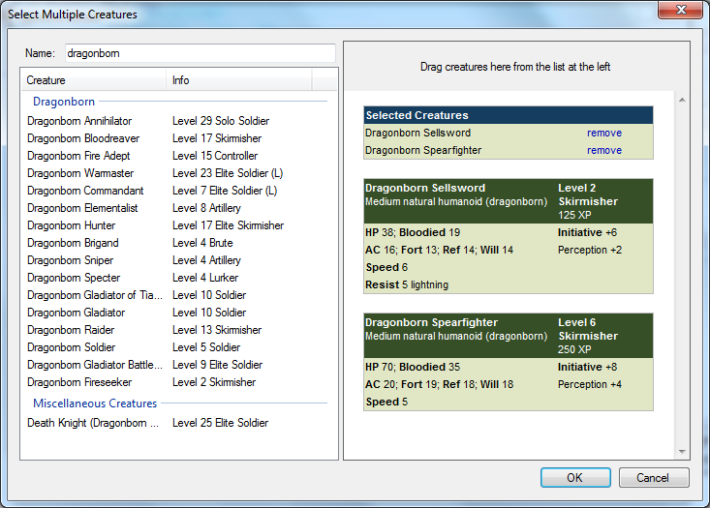

## Checklists

The map tile and miniature checklists (both available from the Tools menu) give you a quick overview of the tiles and minis you need to run the adventure – you can also filter this by subplot.

The map tile checklist shows the number of each tile you need to build each map, while the minis checklist shows you the creatures in each encounter (providing you with keywords and power names to help you pick out the perfect mini).

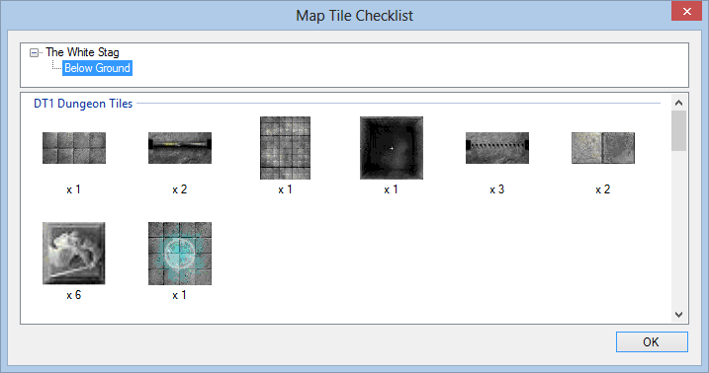

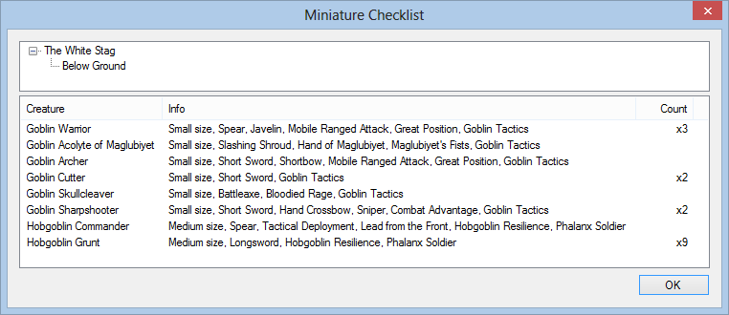

## Import / Export

### Export Handout

You can create player handouts by selecting the **Export Handout** option on the **Tools** menu.

Player handouts can contain:

* Background information items
* Encyclopedia entries
* Player options

The Background, Encyclopedia and Rules pages all have a **Share** menu with a **Publish** option; select this to quickly add all the information from this page into a handout.

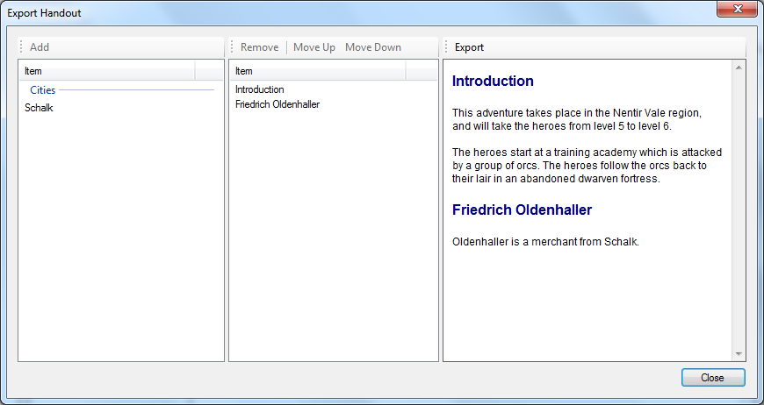

In this screen the available handout items are shown in the list on the left. Drag items from the left-hand list into the centre list to add them to the handout; they can be reordered using the **Move Up** and **Move Down** buttons. The resulting handout is shown at the far right; press **Export** to save it as an HTML file.

### Importing a Project

You can use the **Import Project** command on the **Tools** menu to select a project and add information from it (plot structure, maps, etc) into the current project.

### Export to HTML

You may prefer not to have your computer at the gaming table; for this reason, Masterplan provides the option to save your project as an HTML file. To do this, select **Export Project** from the **Tools** menu.

### Exporting a Plot Point

You can save a plot point as an HTML file by selecting **Export to HTML** from the **Share** menu at the right-hand-side of the workspace page.

You can also export a plot point as its own Masterplan project file, by selecting **Export to File** from the **Share** menu. The resulting file will contain all the information needed for that plot point.

### Exporting an Encounter

Some third-party tools, such as inCombat, can import and use encounter files from Masterplan. To create an encounter file, open the encounter builder and select **Export Encounter File** from the **Tools** menu.

# Libraries

Libraries contain sourcebook information – creatures, creature templates, traps, skill challenges and map tiles. You can browse your libraries by selecting **Libraries** from the **Tools** menu.

Items can be moved between libraries using drag and drop; if you have a project open, the project will also appear so that items created in the project can be copied into external libraries for use in other projects.

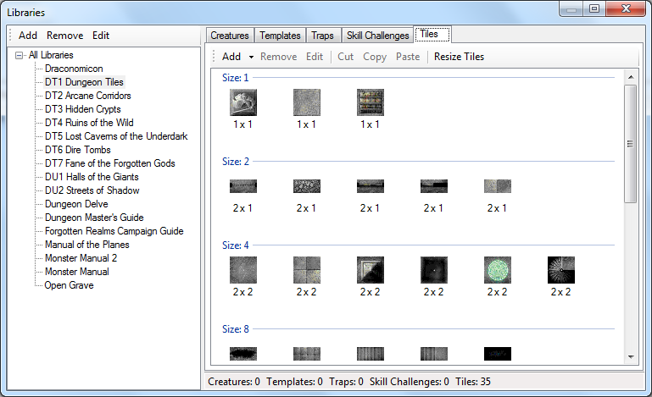

## Creatures

To add a new creature, select a library. Turn to the **Creatures** tab and select **Add** from the toolbar. You can now enter the creature’s name, level, role, and so on. When you press OK the creature will be added to the library and can then be used in encounters.

## Creature Templates

To add a new creature template, select a library. Turn to the **Templates** tab and select **Add** from the toolbar. You can now enter the template’s name, role, statistic modifiers and powers. When you press OK the creature template will be added to the library and can then be used in encounters.

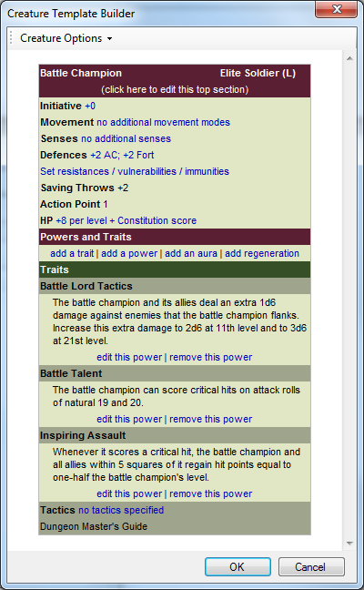

### Monster Themes

You can also create monster themes to apply to all the creatures in an encounter. To add a new theme, select a library. Turn to the **Templates** tab and select **Add Theme** from the **Add** button on the toolbar.

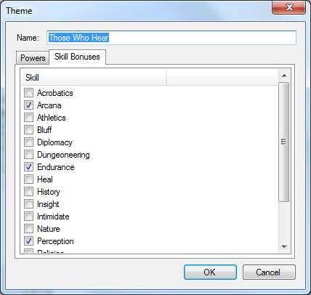

## Traps / Hazards

Libraries can hold predefined traps and hazards. To add a trap or hazard, select a library. Turn to the **Traps / Hazards** page and select **Add** from the toolbar. You can now enter the information for the trap.

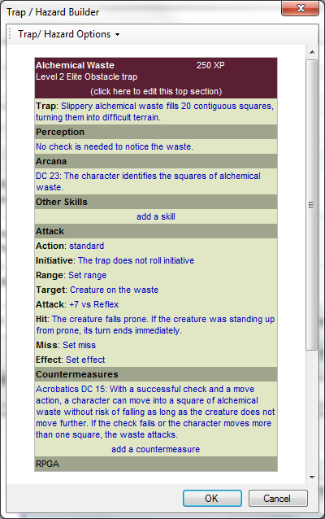

If you want to quickly adjust a trap’s difficulty, you can use the Level + / - buttons at the top right of the screen.

## Skill Challenges

Libraries can hold predefined skill challenges. To add a skill challenge, select a library. Turn to the **Skill Challenges** page and select **Add** from the toolbar. You can now enter the information for the skill challenge.

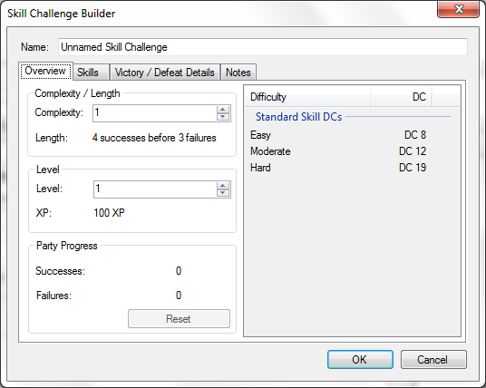

The level and experience sections on the first page will be greyed out; when the challenge is added to a plot point or encounter the challenge’s level will be set and this information will be visible.

## Magic Items

Libraries can contain magic items, which are used in treasure parcels. To add a new item, select a library. Turn to the **Magic Items** tab and select **Add** from the toolbar.

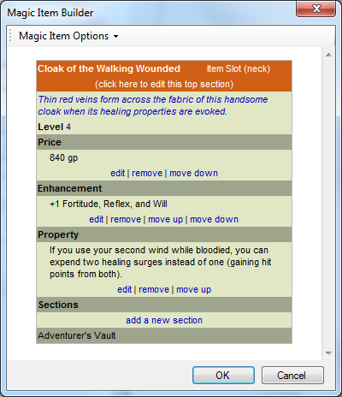

## Map Tiles

To add a new map tile, select a library. Turn to the **Map** **Tiles** tab and select **Add** from the toolbar.

You can now enter the tile’s dimensions, set the tile category (plain, doorway, stairway, feature or special – see the section on autobuilding maps for details) and, if appropriate, any keywords that you might use to describe the tile’s contents.

You can press **Browse** to select an image file to be used for the tile, or set the colour to be used for blank tiles.

When you press OK the tile will be added to the library and can then be used to build maps.

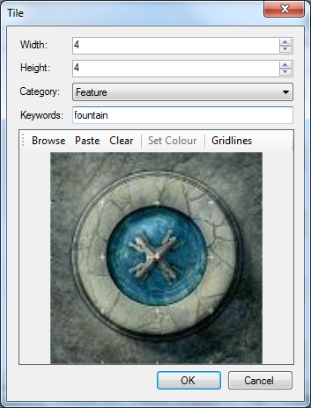

### Adding Multiple Tiles

If you have a folder containing a number of image files to be used as tiles, you can add them all in one go by selecting the **Add Folder** option. Select the folder containing your tile images, and a tile will be added to the library for every image file in that folder (supported formats are BMP, JPEG, GIF, PNG and TGA). The system will attempt to determine the tile dimensions automatically, but it’s a good idea to go through the list of tiles to check this and make corrections as needed.

When you load a folder in this way, all the tiles will be labelled with the ‘Special’ category by default. The map autobuilder does not use tiles which are in this category, so if you want these tiles to show up in the autobuilder you will need to go through and change the category of your new tiles.

## Terrain Powers

Libraries can contain terrain powers, which are used in encounters. To add a new power, select a library. Turn to the **Terrain Powers** tab and select **Add** from the toolbar.

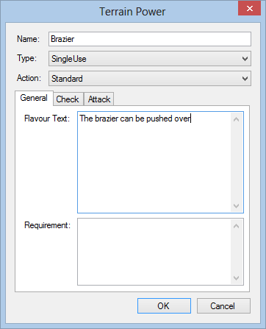

## Artifacts

Libraries can contain artifacts, which are used in treasure parcels. To add a new artifact, select a library. Turn to the **Artifacts** tab and select **Add** from the toolbar.

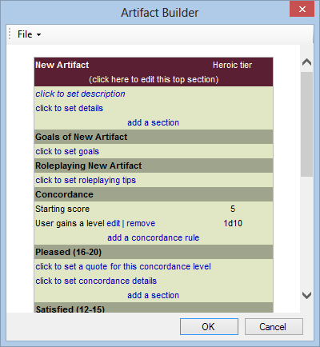

## Import / Export

You can import and export any item in any library. Note that if you have created creatures using the WOTC Adventure Tools suite you can import them into your Masterplan libraries.

* **To export**: Select the item you want to export, and select **Export** from the **Tools** menu on the toolbar.
* **To import**: Select the library you want to import into, then select **Import** from the **Add** menu on the toolbar.

## Demographics

You can get a quick overview of the items contained in a library by selecting **Demographics** from the **Tools** menu in the toolbar. This feature is available for Creatures, Traps and Magic Items.

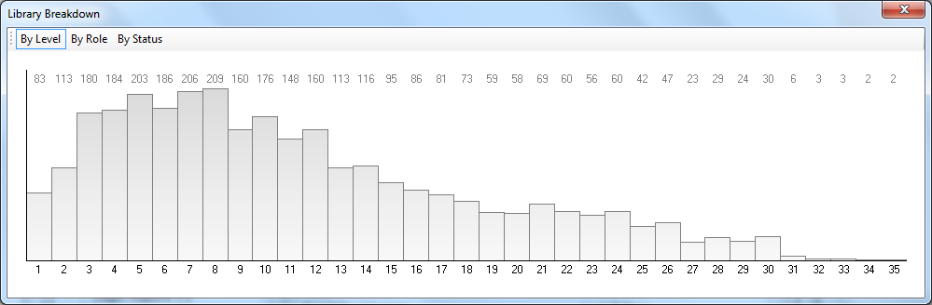

# Password Protection

If you are concerned about other people viewing your plot, you can give your project a password. To do this, select **Password Protection** from the **Project** menu.

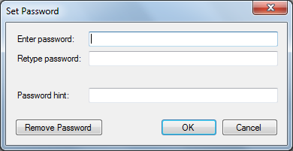

When a password is set, it must be entered whenever the project is opened.

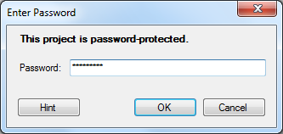

# Customising Masterplan

## Style Sheets

You can create custom style sheets for Masterplan to customize the look of the application.

* Export any element to HTML and copy the contents of the <STYLE> section.
* Create three files containing this copied text in the Masterplan folder:
  + Style.Small.css
  + Style.Medium.css
  + Style.Large.css.

Masterplan will now use these style sheets for text in the application and on the Player View.

## Add-Ins

You can extend Masterplan by writing add-ins for it using any supported .NET language.

* In Visual Studio, create a new class library project.
* Add a reference to the Masterplan application.
* Create a new class which implements the **Masterplan.Extensibility.IAddIn** interface.

Full API documentation is provided in the Masterplan.chm file.

When your DLL is added to the Masterplan\AddIns folder (which you may need to create), the add-in will be loaded into the program the next time it runs.

# Portability

Masterplan is fully portable; if you move your Masterplan folder onto a USB stick you can run the application from any device that has .NET 3.5 installed.

In addition, each Masterplan project file contains all the necessary library items it requires (creatures, map tiles, etc) so you can even open your project with a copy of Masterplan that has no libraries installed.

However, library files themselves cannot be moved to a different machine; this is to prevent copyright infringement issues.